Developing Community and Building Knowledge Online Using a
Virtual-Reality Environment and Student-Created Videos
Eileen A. O’Connor
Empire State College, State University of New York

Within an online science-teacher education course, an important although secondary goal was to prepare students for a high-stakes licensure portfolio at some time after course completion. Thus, various communication technologies including synchronous virtual-reality meetings and asynchronous student self-created video commentaries were interwoven to foster a community of problem solvers. This study examines the several technology-communication venues for evidence of student interpersonal communications and emerging content knowledge concluding with ways these communication tools might effectively support productive learning communities and engender professional yet “safe” and trusting environments in online and blended course environments.
Key words: virtual reality, video, knowledge building, community, online, virtual learning

Literature Review

Context and Instructional Requirements
Teacher-preparation programs in New York State (NYS) are challenged to ensure that their students can demonstrate important research-based practices both during their instructional exercises within a course and later during an independent, externally-reviewed portfolio, known as edTPA, http://www.edtpa.com/. To complicate this challenge, schools where these students (new or soon-to-be-teachers) are working are seldom the instructional environments where these practices can be seen (Binns & Popp, 2013). Although some higher-education faculty (Cronenberg, et al. 2016) decry having to also focus their instructional efforts towards an external-assessment, the instructor for this online graduate teacher-education course sought to use interactive and community building e-tools to create a student community that could develop the knowledge of best practice and of portfolio preparation. What does research suggest about using distance, communication-supporting technologies, such as virtual-reality environments and student-created video, to increase student participation and motivation to learn and to engender the type of knowledge-building needed to prepare students effectively for post-course testing requirements?

Virtual Reality Environments for Presence and Learning
With the advent of virtual-reality environments that participants join as avatars and that can be downloaded essentially as completely functional meeting spaces (O’Connor & Domingo, 2017), instructors can use these environments to overcome the isolation noted by Vesely, Bloom, & Sherlock (2007) in many higher-education online courses. Virtual-reality environments have been long known for encouraging the social aspects of interactions among the avatar participants. Vezina, IsaBelle, Fournier, Dufresne & Doucet (2004) noted that three-dimensional environments created a socio-affective experience similar to a face-to-face classroom. Similarly, instructors who were early adapters of virtual environment, such as O’Connor (2010) or those interviewed by Wilde (2010), reported positive social, collaborative, and community supportive results. The motivational aspects of joining within such environments has been noted as well. Research by Woods et al. (2005) examined how the use of existing online role-playing games, such as one situated in an Antarctic environment, provided an academic setting that supported the students sense of presence and served as an intrinsic motivation for participation. The motivation came, in part, from the sense of connection among participants. In a pilot study of a simulated university setup in a 3-D virtual reality environment (with a mobile interface), McArdle, Monahan & Bertolotto (2007) found that students were able to explore and use the environment with relative ease and reported that students felt more connected to their colleagues than in other online environments.
The immersive nature of the virtual-reality environments can allow participants to envision themselves within these environments While examining community aspects of virtual environments, Martin (2014) posits a belief that younger students, from their prior virtual experiences, will be more motivated to participate in virtual settings because of the “telepresence” they experience in virtual reality environments. According to Chertoff, Schatz, McDaniel & Bowers (2008), presence occurs when a person is unable to differentiate the sensory information created by a hardware-mediated environment from that of reality, interpreting the virtual input as though it were from the real world. Reinforcing the authenticity of virtual interactions, a survey conducted by Barker (2016) of over 200 virtual world users found that these users reported that the virtual environment itself was optimal for distance interactions. Could virtual reality interactions engender Greenwald’s (2016) vivid proclamation: “I want a networked virtual theater where I can watch a movie next to my friends across the country, riffing with them as we look up at the same screen from adjacent virtual seats” when he reported on 3-D headsets in PC Mag, Australia?

Student-Self-Video as an Emerging Area
Within an online course, students can also participate in discussion postings by uploading self-created videos where they address a course topics in video statements and then respond to colleague’s posting using the text discussion format. In their analysis of educational literature about effective online discussions and interactions, Bishop & Hong (2012) concluded: “The interactions between students and their fellow online learners, as well as students with their instructor, through creative engagement will increase their learning experience and academic achievement.” Therefore, at least potentially, a video statement by a student within an asynchronous discussion posting could foster greater connection among students despite distance and time separation. Macharaschwili & Skidmore (2013) studied a face-to-face class where a distance student was video-streamed into the class using Skype, finding that this approach worked well in this particular class. Smith (2016) reported how K12 students self-videotaped reflections on their own learning process during a project, provided the teacher with insights as to the students growing awareness and understanding, understandings that would be hard to measure in other ways. And physiotherapy students who created self-videos of their clinical learning experiences, where they then analyzed their own work against a peer benchmark, were found to have a significant positive experience that improved their practice (Maloney, Storr, Morgan & Ilic, 2013). Although educational research could not be found about video furthering the community-building aspects within the course, published studies did suggest that students could become more reflective through these self-videos and that instructors could have an opportunity for assessment of student deeper understanding as well.

Instructor Scaffolding
Technology tools themselves though cannot create community or meaningful learning. Instructors must challenge students using instructional problems and non-traditional approaches since, according to Barber, King, & Buchanan (2015): “Students are wired in, and our instructional strategies need to acknowledge that keeping their attention requires us to use some of the same engagement strategies that are used so successfully by social media, video games and digital environments” (p. 65). Instructors must create the ill-solved problems that students will need to explore within their online communities (Barber et al. 2015). They must provide the scaffolding for the type of knowledge that their students should build (Yücel & Usluel, 2016). Garrison & Arbaugh (2007), in noting the contributing components of cognitive, social, and teacher presence with the community of inquiry framework, found that the teaching presence must be evident to create the common purpose and for “moderating and shaping the direction of the discourse” (p. 168). Richardson & Lowenthal (2017) expanded the community of inquiry framework to note how the instructor social presence as well as teaching presence is particularly critical for online communities. In properly designing for online discussions, instructors must plan to “facilitate the discussion to allow for organic conversation to develop” such as finding ways to have students use both video and audio comments (Howard, 2016).

Methods
This section presents the overall course background, the components of the course relevant to this student-interactions study, the questions addressed in this analysis, and the approach used to examine the instructional data that was gathered.

Background and Purpose
This study of the role of virtual, video, and interactive approaches to community building and to knowledge acquisition took place within a 100% online graduate course in science pedagogy for K12 teachers, comprised of 14 students who were either new teachers or preparing to become teachers, as summarized in Table 1 below.

Table 1
Students' Demographics
Students in Course
Category | Data
Number of students | 14
Age range | Late 20’s to mid 50’s
Male / Female | 6 / 8
Teaching* / not teaching yet | 7 / 7

* Six students were the teacher-of-record. One student was a resident in another teacher’s classroom
This course had multiple goals and objectives including helping both new teachers and preservice teachers in the development of science units that use research-based practice and, somewhat secondarily, preparing these teachers for a high-stakes portfolio, known as edTPA, https://www.edtpa.com. To be licensed in New York State (NYS) teachers must pass edTPA, which they take independently at some time after the course depending on the student’s schedule. During the course, these new teachers and preservice teachers from around the state worked through assignments and interactions designed to meet the specific objectives for each course module. The course had been built upon the principle of a professional community of practice where the students would share their K12 classroom challenges, their struggles to create and implement inquiry-based practice despite little evidence of these practices in their own experience (Binns & Popp, 2013), and, their growing understanding of edTPA. Despite the distance nature of the course, it was threaded with interactive communication aspects that included online discussion boards with required examination of topics related to lesson development and to K12 classroom practice; self-created videos where students presented their personal ideas on the assignment-prompted education topic; virtual-reality group meeting where, after an initial instructor launch, students worked in groups to explore topics; and, webinars that primarily served as a means for the instructor to deliver content.

Interaction Areas Studied: Virtual Reality Meetings and Final Student Self-Video
The virtual-reality group meetings and the final student-video (where students shared their concluding course perspective) were considered to have best furthered the instructor determination of the students’ understanding of research-based science teaching and of edTPA expectation. During the three synchronous virtual-reality meetings that were interspersed throughout the course, the instructor opened the virtual meetings reminding the students of the broad topic from the edTPA handbook that would be discussed within their breakout groups (as are shown in Figure 1 below). 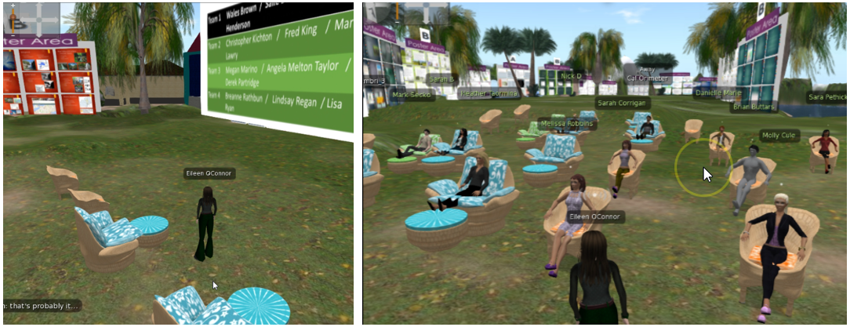
Figure 1. Instructor reviewing slides (left) / Students gathering for whole-class meeting (right)
The student groups reviewed the topic and one student, the documenter, summarized the group’s understanding and questions and posted this summary in a loop-back to a discussion board in the course. During the week, students returned to the course discussion board and extended the conversation about the edTPA topics within this forum. Since passing the edTPA portfolio assessment is a crucial part of the journey of these new and preservice teachers to licensure, the students were concerned about their understanding of the lesson content and the video process that they must demonstrate during their edTPA work. (During the edTPA portfolio process, these new teachers must upload and explain a video of their K12 students working during a science lab that demonstrates research-based approaches.) The instructor visited the various groups during the virtual-reality session (see Figure 2 below) and video-recorded her conversations with the different groups, distributing this recording later so all students could benefit hearing from her direct response to questions raised by the different groups. The instructor and students extended their conversations during the looped-back interactions in the course discussion board. 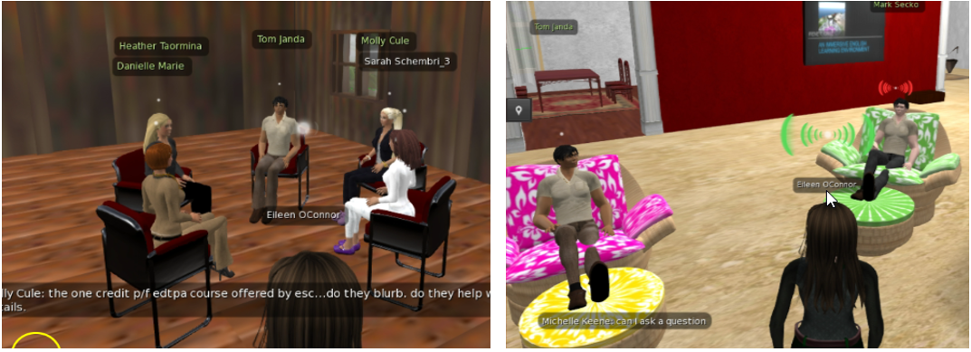
Figure 2. Instructor visits to student break-out groups
During the introduction of the virtual-reality meetings, the instructor emphasized the need for diligence in understanding of edTPA and of the K12-video component, encouraging students to address the complexity of the content and process requirements; her intention was to create a problem-solving, professional community among the students. As the virtual-reality meetings progressed during the semester (coupled with the looped-back discussions), the instructor became aware of a number of areas were students were confused about the edTPA requirements and wanting to be sure that all students understood these requirements she conducted and recorded a required webinar to address misconceptions that had arisen.
The other course area considered most relevant to instructor understanding of student learning issues was the final student video. By this point in the course, these new and preservice teachers were quite comfortable with their colleagues and, as will be demonstrated in the Findings section, they shared videos that addressed the assignment requirements – to reflect on learning and on K12 classroom practices – in ways that were both educationally productive and socially convivial. The schematic in Figure 3 below illustrates the course interactive elements deemed most central to the knowledge building of the students as they prepared for their eventual high-stakes portfolio preparation.
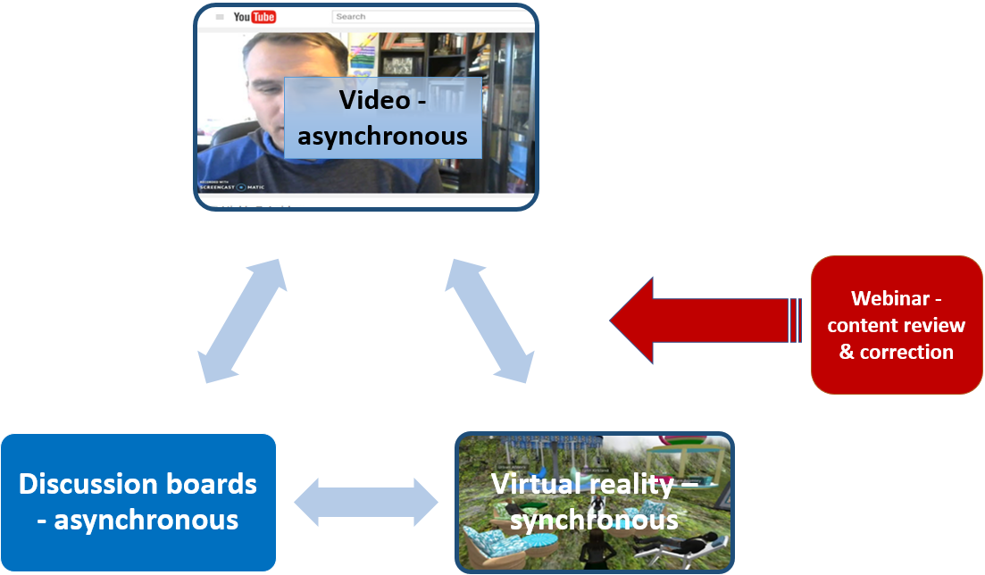
Figure 3. Online interactive components most relevant to the study

Questions Raised about the Course and the Interactions
To help determine what course components and interactions were most effective, the following questions guided the analysis:
- How did the use of varied online virtual and video interactions further the course goals of supporting best-practice lesson creation, of preparing students for a high-stakes portfolio that would be taken at a later time, and of creating a professional community?
- How was community and learning evident within these online environments?
- How did these interactive, distance elements provide opportunities for instructor observation and intervention towards achieving the required knowledge?

Analysis Approach
In addressing the questions about course purpose and interaction support, the instructor (who is also the author of this paper), after procuring authorization for the study of course content from the school’s Institutional Review Board, reviewed the entire course, assignments, and interactions. From this review, the instructor determined that the virtual-reality meetings with online follow-up (the loop back) and the concluding student video where they reflected on their learning were the areas that provided the greatest evidence of the community and learning aspects related to the content and process associated with the high-stakes portfolio. The student video segments were transcribed and the student statements were reviewed to find recurring instructional and social statements and themes. Using a constant comparative method to generate a grounded theory (Strauss and Corbin, 1990), the instructor then organized the different statement categories and coded them within a spreadsheet, thereby allowing a count of the students who brought forth these statements. Similarly, the verbal interactions of the instructor and students during the virtual reality meetings (which were videotaped) and the subsequent loop-back reports and discussion within the course were analyzed for student comments and instructional statements and for edTPA understanding. The resulting data was sorted and analyzed generating the information that is examined in this paper. Descriptive statements from students were gathered too, as relevant, to illustrate and expand upon selected patterns that were revealed.

Findings, and Interventions
As explained in the Methods section (see Figure 3 above), the virtual-reality meeting with the looped-back extensions and the concluding student-video commentary provided the strongest evidence of knowledge and community building. Although the development of a community was evident in numerous locations, for the purposes of this analysis, it was studied in a systematic way in the student-video commentaries and is addressed at the end of this Finding section. Since it is important to understand how the instructor addressed misconceptions that occurred, the remediation webinar is highlighted here as well.

Virtual Reality Meetings and Loop-Back: Instructor Becomes Aware of Student Understanding
During the three virtual-reality meetings, students initially listened to an overview of the topic for discussion provided by the instructor, as shown in Figure 1 above. Students then separated into groups discussing the topic and the instructor in turn visited the different groups as shown in Figure 2 above. Within the week following the meeting, students posted their group’s discussion notes and extended the discussion within the looped-back discussion area. Students statements, interactions and comments over this three week time period are summarized in Table 2 below. Trying to avoid a “teach to the test” approach with edTPA preparation (as decried by Cronenberg, et al, 2016), the instructor established an initial topic area within edTPA and then had the student groups examine and discuss the edTPA handbook requirements to develop their own understanding.

Table 2

Emerging area summary; found within the virtual-reality/loop-back interactions
Topic | Areas considered
Video creation logistics | Camera movement & placement
Video content – misunderstanding | Student must be center / not teacher; teaching via “inquiry”
Video creation process - misunderstanding | Planning / staging students for the camera; getting students camera comfortable
Assessment considerations | Types of assessments allowed? Uses and applications
Disagreement within groups | Interpreting handbook differently – clarification requested

What emerged from the student group conversations was a mixture of:
- useful, productive, practical discussions such as on video preparation and logistics where the students considered effective ways to videotape the laboratory interactions ensuring that the resulting tape would be sufficiently audible and would have suitable K12 student focus;
- conceptual misunderstanding such as conflicting perceptions of the type of teaching and of K12 student behaviors that should be evident particularly since the inquiry-based approaches that were to be demonstrated in the videos was often antithetical to approaches used in K12 classrooms (Binns & Popp, 2013); several students brought forth these pedagogical/cultural differences during the virtual visits of the instructor to their groups and later during the loop-back discussion postings;
- procedural misunderstanding that could result in a poorly-taped video such as leaving the camera in one single location during the lesson or that could even lead to edTPA invalidation such as when one student explained that a seasoned teacher at his school suggested staging a classroom lesson with the best students and a pre-run lab, which would be strictly forbidden;
- knowledge-building conversations such as when some student groups reflected on ways to create and then explain effective assessment practices discussing what evidence might be considered acceptable to the edTPA reviewers;
- unresolved areas where student groups could not come to agreement about what the edTPA documentation was actually requiring – in these cases, points were brought forward to the instructor for interpretation and clarification either during her visit to groups or later in looped-back discussion.
The high-stakes nature of the edTPA portfolio – which would be required for licensure, which would be taken individually by students independent of the teacher-education institution, and which would be evaluated by reviewers that did not know the student—had the course participants suitably concerned about their interpretation of the edTPA expectations. The looped-back discussion shown below illustrates the students’ concern about understanding the correct instructional approach and taping logistics:
George: you say "don't want to see teachers" is this correct? I realize the students need to be shown, but shouldn't the teacher also be shown interacting with the students? In the Literacy class we are watching a video by Tovani and she is shown prompting the students often and they give lots of good responses that I think would be good for edTPA. The response of the student is what's important, but it is the interaction with the teacher that helps create the response.
Reply to George by Jennifer: I agree with you, George. I think an important part of this is witnessing the scaffolding that the teacher supplies during the discovery that the students are making. I believe "don't want to see the teachers" refers more to "don't show a lecture or a long teacher demo." That is my opinion so let's see what other people think.
Reply to Jennifer by Samantha: I interpreted it that way too, Jennifer. I would assume that the teacher should be sprinkled into the video asking leading questions or trying to draw more conversation out of student groups, but should not be feeding them answers.
An analysis of the virtual-reality initial and extended discussions unearthed students beliefs about their eventual high-stakes assessment.

Remediation Webinar
Having become aware of the students’ perspective on edTPA and on preparation practices for this portfolio, the instructor wanted to ensure that all students misconceptions were addressed and that useful strategies were supported. Concerned that students might not all see her postings and corrections, knowing that instructors can be misled into thinking all students are aware of instructor discussion postings, she conducted a Remediation Webinar to address points that had emerged during the virtual-reality sessions. Although webinars are often instructor dominated, with little direct participation by students and with scant understanding of the webinar-participant’s knowledge gained, the instructor targeted areas that had been revealed as weak or confused in the student thinking providing clear and hopefully-meaningful information. The one student who could not attend the webinar watched the taped version later.

Concluding Student Video: Community Evidence and Knowledge Integration
The final interactive element within the course itself was a student-developed videotape where they reflected upon their overall learning in the course and, as stated within the course assignment, addressed: “lessons learned about good teaching practices during the semester, particularly if the learning was prompted by the required exercises from edTPA.” Table 3 below summarizes the areas that became evident from the transcribed student reflections, indicating what aspects were brought forward in the initiating student video and what comments came forward during the discussion board interactions that followed upon the student’s review of their colleagues videos. (Note: although 14 students were in the entire class, one student did not participate in the final video assignment.) The order of the topics in the Table 3 below is based upon the frequency of its occurrence among the overall comments.

Table 3

Emerging Areas in the Final Student Videos Ranked by Frequency of Occurrence
Areas Student Raised
Final video topics raised: | In Video | In Comments | Note:
Addressed the class personally | 13/13 (100%) | 6/13 (46%)
Shared general teaching tips | 8/13* (62%) | 3/13 (23%) | * Presently teaching plus one from past teaching
Complexities of reform-based teaching | 7/13 (58%) | 6/13 (46%) | Multiple issues, challenges & solutions
Greater comfort with edTPA process | 6/13 (46%) | 3/13 (23%)
Videotaping K12 students – issues and logistics | 4/13 (31%) | 2/13 (15%)
Science writing & communication | 3/13 (23%) | 4/13 (31%) | Challenges observed
Improved perspective on assessment | 3/13 (23%) | 3/13 (23%)

Although only addressed anecdotally here, students throughout the course, expressed their satisfaction with the self-video process where they actually were able to connect on a personal, visual level with colleagues. Interestingly, although students were asked to create only 3 to 4 minute videos, most students went significantly over the time limit. As noted in the Table 3 above every student in their video referred specifically to their course participants indicating how much they learned and how appreciative they were of their colleagues’ presence, ideas, and support throughout the course. Almost half of the students in their discussion-board responses extended their personal thanks for colleagues contributions. By the end of this course, this final interaction provided collegial evidence of a community of practice where students took the time to actually express and often even specify the help that colleagues had offered. Noteworthy is that several students mentioned specifically their willingness to share awkward, embarrassing, complex new-teacher problems because they felt “safe” in their course environment (Eggs, 2012).
Although students were not asked to indicate any specific teaching practice or course components, the following areas emerged among the topics discussed in the initiating video and in the extended comments.
- shared teaching practices — all seven students who were in classrooms, and one student who was in the classroom prior to this particular course, brought forth very specific and often concrete examples of ways to alleviate the challenges of being a new teacher;
- reform-based teaching challenges — almost 60% of the students reviewed their victories and concerns about inquiry-based teaching, some pointing out how their K12 student populations have had little experience with student-directed learning in their school culture (echoing the findings of Binns & Popp (2013)) and others mentioning ways to increase student-relevant science experiences; conversations extended into the comments or ongoing suggestions for how to bring these practices into current teaching;
- greater understanding of the edTPA process — almost half the students volunteered that they felt less intimidated by the high-stakes portfolio, which they must pass to become licensed in NYS, indicating how course work and colleague comments had help them know better how to prepare;
- videotaping the K-12 students — about a third of the students still delved into very specific points about the videotapes that they would need to create of their actual students work for the high-stakes portfolio, showing a good understanding of what must be evident while still reflecting upon the challenge that it raises in the classroom;
- writing and communication —three of the students mention explicitly their concerns about having students communicate clearly and fluently within the science subjects and almost a third of the students commented upon their own challenges with encouraging appropriate scientific-level communications within their classroom; science-communication fluency is required by reform-based science practices and should be evident in the actual edTPA submission;
- better assessment understanding — and about a quarter of the responses and comments indicated how the students now felt more aware of the role of assessment in effective teaching practices.
After having reviewed the student self-videotapes and the subsequent discussions, the instructor felt reasonably assured (in an informal, formative way) that the students had, at this point in their journey towards classroom teaching, a useful and reflective awareness of the challenges presented by reform-based teaching and by the eventual evidence they would need to submit to edTPA when attempting to procure their teaching license. However, from a practical perspective, students would not take their portfolio-licensure step for one to even three semesters later, so the lessons-learned would have to stay with them for some time after the course had ended.
Between the virtual-reality interactions and the concluding student-created videos, sufficient evidence appeared to have emerged to provide the instructor with a useful, developmental awareness of complex student thinking within a 100% online environment.

Discussion
A review of the findings from the virtual reality interactions and the final student-video posting suggested areas where these formal yet friendly interactions appeared to have furthered the hoped-for eventual accurate development of an understanding of both the content and documentation-process needed for effective classroom practice and for success on the high-stakes, post-course portfolio. Several social-interaction elements appeared to have contributed. These areas will also be considered in light of the guiding questions that help to organize this study.

Creating a Community Experience Online Through Virtual Reality and Self-Video
The student interactions, comments, and video-disclosures showed a cordial, collegial respect and a concern for developing reform-based practices. Since the instructor was able to circulate among the different discussion groups during the virtual-reality meetings (as shown in Figure 2 above), she was able to hear directly the understanding, concerns, and questions from the groups of students that were assembled. Furthermore, since the students had already been talking with their team members before the instructor visited, they were able to articulate focused concerns about what they needed to do in their classrooms to prepare for the teaching and learning that must eventually be shown on videotape during their high-stakes portfolio. Also, working within the socially-comfortable virtual environment might have mitigated the concern about discussion board posting where students “may be somewhat intimidated by what they view as student postings better than their own” (Sull, 2012). The students appear to have the foundation for the trust, noted by Eggs (2012), needed for a productive learning community.
Furthermore, having this opportunity to work real-time with students to address questions, allowed the instructor more of the familiarity and understanding/disclosure that can happen within face-to-face environments. And, the students were afforded the opportunity to assemble their thoughts and concerns within the “privacy” of their group before the instructor came to talk with them. This diffusion of authority possible within group meetings in a virtual environment can ameliorate the often instructor-dominated formats of webinars and even streamed-video sessions (such as Skype or Zoom). The comments brought forward by students during these virtual sessions and loop-backs, as summarized in Table 2 above, suggest an honesty and openness that provided the instructor with a most productive informal assessment opportunity, as considered in the next section.
Throughout the course, the students had also been participating in self-taped video sessions where they discoursed personally on the required topic, posting their video and responding to the videos of other students. These discussions generally received rich and productive feedback from course participants as well. The final self-taped videos were analyzed in the Findings section and it was found noteworthy that all the student-videos provided strong evidence of caring and supportive interpersonal connections in the statements made. Students were honest about their classroom challenges and fears, if they were teaching, and were forthcoming with suggestions for teaching and for portfolio preparation (as considered more below). Observing that this professional conviviality carried through to the end of the course, continues to support the premise of Eggs (2012) about the need for a trusting environment if a genuine community of practice is to develop among these soon-to-be or new teachers.
It is not possible from the scope of this analysis to determine with precision the weighted contribution that the various collegial-building course elements provided, however, the accumulative effect within this online course, as demonstrably evident in the final video, was of a productive professional community that had the potential of extending beyond the course. As was noted in a publication that originated with Vygotsky (1978), individuals working through similar challenges may be able to help each other in their understanding.

Understanding Potential Student Challenges Through Virtual Reality
The course under study was primarily focused on developing effective and research-based science teaching practice. A secondary goal was to make students aware of the requirements for demonstrating their mastery of these approaches within a licensure-granting portfolio assessment that they would take some time after the course completion (from 4 months to 2 years later). The instructor designed the course to provide opportunities for student discussion and knowledge development during the virtual-reality meetings since there would be time for focused, synchronous discussion among groups and for her moderating the different groups as she visited their locations. The familiarity and honesty among the students, as noted in the previous section, allowed her to have insights into the actual, developmental thinking of the student groups in ways that are generally only possible in face-to-face settings. The postings of the groups’ discussion items later too in the loop-back provided the instructor with further insight into students’ thinking.
From the information summarized in Table 2 above, students had misunderstandings about the process of taping the K12 students themselves within their own classroom settings. The edTPA handbook (over 50, single-spaced pages of detailed procedural information) provided concise information about what would have to be evident in the video segments. From their understanding and interpretation, the course participants discussed camera types, taping angles, ways to get good sound quality, and the like. Erroneous ideas emerged too about how to find the “perfect” K12 student scenario to tape for these scoring reviewers (who would only know the K12 student behaviors through two short video segments). Students also talked about the challenges of inquiry-based teaching and having the K12 students speaking with appropriate terminology and scientific reasoning. The virtual-reality discussion focus had been designed to engender the higher-level, problem-solving thinking that was needed to adapt the comprehensive portfolio instructions into practices that these students could implement and demonstrate in their future teaching.
Students also had the more challenging task of ensuring that their edTPA lesson demonstrated research-based, best-practice. As students discussed in the virtual environment and extended well into their final self-taped video, there were the struggles with guiding K12 student to inquiry about science phenomena and not simply follow lab directions and with ensuring that the K12 students communicated their lab findings with data and charts and with appropriate scientific language. The instructor was confident that she had unearthed the important areas that students would need to address and that, from a scaffolding perspective, the students were ready to assimilate solutions for the problems that they had raised. Thus, as noted by Garrison & Arbaugh (2007), to develop a productive community of inquiry, the instructor needed to provide direction, moderation, and shaping. This moderation and shaping of students’ thinking was required to correct some errors that had been unearthed. Although the instructor was able to respond to some misguided postings in the loop-back area and when she heard them from a group directly, she needed to address these errors in ways that would capture the whole class’ attention.
The primary intervention strategy, explained in more detail in the Methods section and shown in the schematic in Figure 3, was the instructor-developed ad hoc webinar that she created to address the areas of weakness that had emerged from the virtual-reality meetings and loop-backs. Although the primarily lecture-driven approach was seldom used by this instructor, she believed that students would be sufficiently attentive (since their ultimate teaching licensure in NYS would be dependent upon passing edTPA) and she delivered a targeted presentation with time for questions and answers about edTPA content and process topics.

Determining and Assessing the Understanding Evident in the Final Self-Video
The ultimate outcome desired for the interactive components examined here was that students would have an accurate, appropriate understanding of edTPA requirements and that they would remember these requirements until a later time when they would actually create and submit their portfolio to external reviewers. Given the complexity of the science practices that needed to be evident in the portfolio-required video, the effectiveness of the instructor’s insight gathering and discussion-response and webinar remediation should be determined. There was no possible direct measurement of learning in this study, because the portfolio would not be completed for some time, the proxy measure of student volunteered understandings during the final self-video served as evidence of emerging understanding. As considered throughout this paper, the honesty and openness of the students suggested that the strength of students’ beliefs and convictions could be evaluated with some accuracy.
As summarized in Table 3 above, the students brought forth the key content issues surrounding the research-based practices that they should be implementing, addressing a sometimes resistant school culture, the lack of science inquiry in most current lab practices, and the challenges of having K12 student create appropriately written science communications. In their self-videos, students initially stated the challenges and often offered suggestions for how to address these areas during these reflections. Comments by colleagues often extended into helpful discussions providing useful and appropriate solutions to the posited school challenges. From the topics that emerged from the students’ self-selected areas it appeared that students had addressed in a forward thinking and genuine way strategies to address the very tangible and entrenched instructional and pedagogical challenges in K12 science education. And, almost half the students put forth that they had a great comfort level with the portfolio process that lay ahead in their progress towards being a licensed NYS teachers.
The interspersing of virtual meetings, self-videos, and discussions appears to have created an open, honest, and revelatory environment that supported instructor understanding, remediation, and evaluation that might have been difficult in a less immersive and interactive online environment.

Conclusions and areas for further study
This study of a science teacher-education online course examined how a complex understanding could emerge over a course within a community of soon-to-be teachers through the use of multiple virtual-reality and self-video processes. The findings suggest possible approaches to designing productive interactions in multi-modal ways within online or blended environments. Since the actual outcomes were specific to the nature and purpose of the interactions within this course environment, generalizations are subject to the limitations associated with case studies. However, understanding the aspects of the instructional design and implementation that contributed to the community that developed suggest possible approaches that could be integrated into online and blended environments.
- virtual-reality meetings structured as peer discussions around course related topics can engender the type of collegial sharing, collaborative problem identification and knowledge building, and instructor oversight that is normally only associated with face-to-face classroom settings;
- the isolated and segmented interactions that can occur in discussion boards (where students are often interacting with only a few colleagues) can be overcome in a virtual-reality environment by creating different groupings during the various meeting times;
- virtual-reality interactions, particularly when meeting topics are shared later with the entire class through discussion board postings, can give the instructor insight into group, collaborative, and problem-solving understanding, thereby informing the instructor of areas that may need more instruction;
- self-video by participants, where they expound on course topics, can encourage more personal ownership and responsibility, thereby supporting deeper learning and more honest communications;
- selecting from and using the more interactive, real-time, and personal e-communication tools available to distance and blended learning instructors provides opportunities for creating customized and ongoing adjustments to knowledge and content building within the course timeframe itself;

using interactive, socially-based online tools can expand a course’s reach beyond the classroom by creating strong and useful professional relationship that could extend beyond the course.

The findings from the study of this course’s community development online interactions suggests that purposeful design of course interactions can provide students with collaborative knowledge building and professional relationships and can give the instructor more ways to develop, guide, and assess student understanding.

Concerns, and Areas for Further Study
Students have often come to expect that online course will mean complete participation flexibility, however, isolation from the instructor and course colleague can be the result. Given the plethora of tools that are emerging for synchronous meetings, instructors need to plan judiciously and creatively for the e-communication tools they can use to stimulate productive interactions on social and academic levels. Further study about the use of virtual-reality meetings (where groups and non-hierarchical organization is possible) and the use of asynchronously developed video could address areas such as: what factors of learners, content, and social technology integration are optimized by various interactive media within a course setting? what types of knowledge building is most amenable to shared, synchronous virtual meetings and discussions? and, how can these planned-for activities be used to their fullest given the time limitations and scheduling restriction incumbent upon online student?

Reference List
Barker, V. (2016). Flow in Virtual Worlds: The Interplay of Community and Site Features as Predictors of Involvement. Journal Of Virtual Worlds Research, 9(3), 1-17.
Barber, W., King, S., & Buchanan, S. (2015). Problem based learning and authentic assessment in digital pedagogy: Embracing the role of collaborative communities. Electronic Journal of E-Learning, 13(2), 59-67.

Bishop, C. & Hong, R. (2012). Building community: effective strategies to increase interaction in online learning. In P. Resta (Ed.), Proceedings of Society for Information Technology & Teacher Education International Conference 2012 (pp. 1106-1111). Chesapeake, VA: Association for the Advancement of Computing in Education (AACE).

Binns, I. & Popp, S. (2013). Learning to teach science through inquiry: Experiences of preservice teachers. Electronic Journal of Science Education. 17(1).

Chertoff, D. B., Schatz, S. L., McDaniel, R., & Bowers, C. A. (2008). Improving presence theory through experiential design. Presence: Teleoperators & Virtual Environments, 17(4), 405-413.

Cronenberg, S., Harrison, D., Jones, A., Murray-Evertt, N., Parrish, M., & Johnston-Parsons, M. (2016). Trouble with the edTPA: Lesson learned from a narrative self-study. Journal of Inquiry & Action in Education, 8(1), 109-134.

Eggs, C. (2012). Trust building in a virtual context: Case study of a community of practice. The Electronic Journal of Knowledge Management. 10(3), 212-222.

Garrison, D. & Arbaugh, J. (2007). Researching the community of inquiry framework: Review, issues, and future directions. The Internet and Higher Education. (10). 157-172.

Greenwald, W. (2016). Why I'm No Longer Pessimistic About VR. PCMag, Australia. Retrieved from http://au.pcmag.com/virtual-reality/42829/opinion/why-im-no-longer-pessimistic-about-vr

Howard, E. (2016). Best Practice in Online Discussion Boards. Lethbridge College Learning Connections. Retrieved from http://www.lc2.ca/item/235-best-practices-in-online-discussion-boards

Maloney, S., Storr, M., Morgan, P., & Ilic, D. (2013). The effect of student self-video of performance on clinical skill competency: A randomised controlled trial. Advances In Health Sciences Education: Theory And Practice, 18(1), 81-89.

Martin, A. (2014). Motivating learners with virtual reality. In J. Viteli & M. Leikomaa (Eds.), Proceedings of EdMedia: World Conference on Educational Media and Technology 2014 (pp. 2631-2636). Association for the Advancement of Computing in Education (AACE).

Macharaschwili, C. & Skidmore, L. (2013). A skype-buddy model for blended learning. Journal of Interactive Learning Research, 24(2), 167-190. Chesapeake, VA: Association for the Advancement of Computing in Education (AACE).
McArdle, G., Monahan, T. & Bertolotto, M. (2007). Using virtual reality to learn and socialise online. In C. Montgomerie & J. Seale (Eds.), Proceedings of EdMedia: World Conference on Educational Media and Technology 2007 (pp. 4225-4234). Association for the Advancement of Computing in Education (AACE).

O'Connor, E.A. (2010). Instructional and design elements that support effective use of virtual worlds: What graduate student work reveals about second life. Journal of Educational Technology Systems, 38(2), 213-234.

O’Connor, E. A. & Domingo, J. (2017) A practical guide, with theoretical underpinnings, for creating effective virtual reality learning environments. Journal of Educational Technology Systems. 45(3), 343 – 364.

Richardson, J. J., & Lowenthal, P. P. (2017). Instructor social presence: A neglected component of the community of inquiry. Elearning & Software For Education, 2531-536.

Smith, S. (2016). (Re)Counting meaningful learning experiences: Using student-created reflective videos to make invisible learning visible during PjBL experiences. Interdisciplinary Journal Of Problem-Based Learning 10(1).

Sull, E. (2012). Tips for Overcoming Online Discussion Board Challenges. Faculty Focus: Higher Ed Teaching Strategies from Magna Publications. Retrieved from https://www.facultyfocus.com/articles/online-education/tips-for-overcoming-online-discussion-board-challenges/

Strauss, A., & Corbin, J. (1990). Basics of qualitative research: Grounded theory procedures and techniques. Newbury Park, CA: Sage.

Vesely, P., Bloom, L., Sherlock, J. (2007). Key elements of building online community: Comparing faculty and student perceptions. Journal of Online Learning and Teaching. 3(3).

Vezina, N., IsaBelle, C., Fournier, H., Dufresne, A. & Doucet, J.J. (2004). 3D virtual reality, motivation, sense of belonging and perseverance. In L. Cantoni & C. McLoughlin (Eds.), Proceedings of EdMedia: World Conference on Educational Media and Technology 2004 (pp. 1677-1682). Association for the Advancement of Computing in Education (AACE).

Wilde, J. (2010). More than a place to meet (virtually): What educators tell us about Second Life. In J. Herrington & C. Montgomerie (Eds.), Proceedings of EdMedia: World Conference on Educational Media and Technology 2010 (pp. 3866-3874). Association for the Advancement of Computing in Education (AACE).

Woods, B., Whitworth, E., Hadziomerovic, A., Fiset, J.P., Dormann, C., Caquard, S., Hayes, A. & Biddle, R. (2005). Repurposing a computer role playing game for engaging learning. In P. Kommers & G. Richards (Eds.), Proceedings of EdMedia: World Conference on Educational Media and Technology 2005 (pp. 4430-4435). Association for the Advancement of Computing in Education (AACE).

Vygotsky, L. S. (1978). Mind in society: The development of higher psychological processes. Cambridge, Mass.: Harvard University Press.

Yücel, U. & Usluel, Y. (2016). Knowledge building and the quantity, content and quality of the interaction and participation of students in an online collaborative learning environment. Computers & Education. 97. 31-48.

