Monroe Community College • State University of New York OOL@monroecc.edu
Monroe Community College: Virtual Campus
February 2015
Attendance Options
Virtual Campus:

Andrea Gilbert and Nancy Haggerty

Option 1: 15-Week Attendance Template (option for 1, 2, 3 days per week)
Process: Download the appropriate zip file based on how many class sessions you teach per week and import it into your Blackboard class. The zip file will be available on Bb Babblings.
Summary: This template is set up for a 15 week semester, but the number of columns will vary depending on the number of days that you teach. Currently we have an option for 1, 2, or 3 days a week. You can add or delete columns as needed depending on your needs. You would need to import the proper template into each class that you teach. It allows you to keep track of attendance for single days of class based on a one point a day which can be modified. You can choose to use or not use the overall total attendance percentage column in your final grade calculations.
FEATURES
Grading Schema: You can adjust the grading schema to reflect your attendance grading system by adding more criteria. Currently, the schema is set to:
What to Enter in the Grade Center
P=Present 100% Present =1 point
E=Excused Absence between 90%-99% Excused= 0.9-0.99
T=Tardy between 50-90% Tardy=0.5-0.9
A=Absent 0%-50% Absent=0-0.5

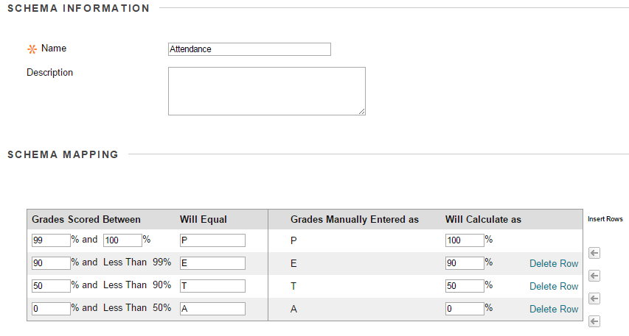
You can add more criteria by clicking the arrow to “insert row” or delete rows as needed.
Edit Column Information: You can edit the column information on each column to change the column name to the date of class (but not necessary if you want to reuse for minimal work next semester). You can also adjust the number of points possible. By default, we set the points possible for each column to 1. It displays a score as the primary display (so they students will see how many points they have for each class, but the instructor will also see the secondary display as P,E, T or A).
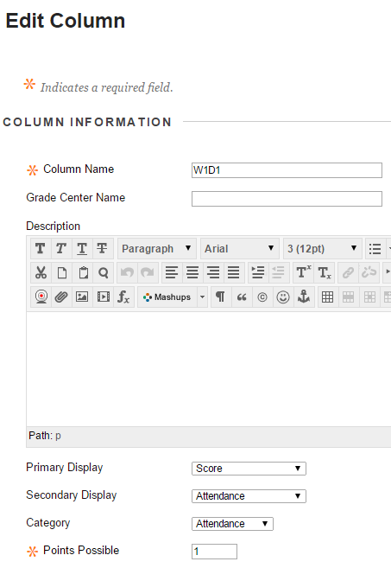
You can edit the name of the column or leave as is for easy management
(W1D1=Week 1 Day1)
You can edit points possible for each class.
Delete Column: You can delete extra columns as needed, by clicking the chevron to the right of the title and select “delete column”.
Display of Total Attendance Grade: You can display a total attendance grade in percentage or score to students and use this column to include in your final grade calculations.
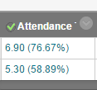
Secondary Display is Percentage
Primary Display is Score
Exempt Status: You have the option to exempt a day of attendance for excused absences or if a student is added late to the class.

Smart View: A smart view called Attendance will be automatically included in the Grade Center. You can use the smart view to sort just the attendance columns in your gradebook (but the overall attendance will not be included in the smart view).
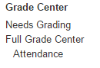
Attendance Smart View

Advantages: The biggest advantage of using this Blackboard attendance template is having your attendance and grades all in one place on Blackboard. Students can directly see their points for attendance for each class and faculty can add quick comments for students to view in My Grades. Faculty can change titles of columns and points easily. Extra columns can be deleted easily. It is helpful to have a good understanding of the Grade Center. Once the template is in the course shell, you can roll it over to the following semester. The columns are contained in a Grading Period called Attendance.
Disadvantages: From semester to semester, the number of class meetings may change so some adjustments may be needed to fit the current course. This template may crowd your gradebook with many columns.
Option 2: 4 column Attendance Template
Process: Download the Attendance Version 2 zip file and import it into your Blackboard class. The zip file will be available on Bb Babblings.
Summary: If you don’t want to deal with the numerous extra columns in your grade center, you can download the 4-column attendance template into Blackboard. Each time a student is present for class, just increase the present column by one. If a student is excused, tardy, absent you can keep track by adding 1 point to the corresponding column. By the end of the semester, the present column will display the total points for attendance with a secondary display percentage. You can add quick comments as needed to keep track of the dates that a student was excused, tardy, or absent.
FEATURES
Running Total: You can keep a running total points (or average) in the present column and set the points possible to the total number of days of class or total points. Each day that a student is present, increase their points in the present column.

Edit Column Information: It is very easy to edit the “Present” Column to fit your class grading structure. You should know up front what your total possible points or number of classes, but this can always be adjusted at any point during the semester.

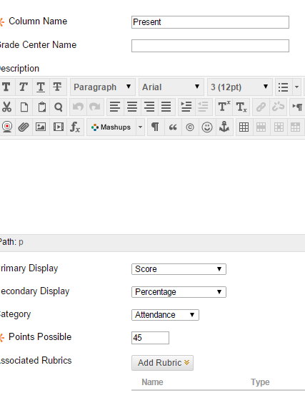
Adjust points as needed. This can be the total number of classes that you expect students to be present the entire semester

Quick Comments: If students are excused, tardy, absent, you can also keep track of these values. Ultimately, you can add quick comments in if students are absent on certain days.
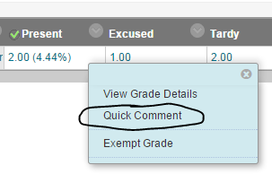

Advantages: With fewer columns to manage, this is a very simple addition to your gradebook with minimal editing needed. Attendance is contained in your gradebook and students are able to see quick comments in their My Grades. You can add the present column into the value of your overall points or weighted total grade. A smart view is added for Attendance for your convenience.
February 2015
Monroe Community College: Virtual Campus
February 2015
Monroe Community College: Virtual Campus
February 2015
Monroe Community College: Virtual Campus
Disadvantages: Be aware of the value before you enter the new score. In case of a mistake, you can also go to View Grade Details and view the grade history.

Option 3: Google Spreadsheet
Summary: Faculty must have some previous knowledge using Google Drive to use one of the attendance spreadsheets. With this final option, attendance can be recorded and stored on Blackboard for teacher reference, however it is not tied to Blackboard’s Grade Center.
Process: We have 3 templates available to copy. Click the link below and copy the google spreadsheet. You will need to have a google account to use this option.
- January-May 2015 M-W-F
Use this if you teach a M/W/F class:
https://docs.google.com/spreadsheet/ccc?key=0AjWirywgFhYidGJya1pycnlhYmYwSk55VFZSbmxOQXc&usp=sharing

- January-May 2015 T-Th
Use this if you teach a T/Th class:
https://docs.google.com/spreadsheet/ccc?key=0AjWirywgFhYidEZBWHBRZ3ZmLWRZNk1DdG5zbHhiTUE&usp=sharing

- Master Template Jan-May which you can edit to fit your class meeting times
https://docs.google.com/spreadsheet/ccc?key=0Alk-RdcH1cRVdEdUalByUHZWZFJDdzhTcU16Y1hWSkE&usp=sharing
FEATURES
Add a Web Link in Blackboard: The template keeps track of days present, absent, excused, and tardy as you would by hand in the roster provided by MCC. It also totals the absences, excused, tardy, and days present. The nice feature of using a google sheet is that you can add a web link on your course menu in Blackboard and hide it from your students:
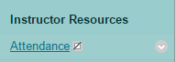

Access Anywhere: This gives you access to your attendance spreadsheet from home or on campus and the changes will take effect immediately; however there is no way for students to see this information.

Copying the Templates: We recommend making a copy of one of the templates to use and rename the spreadsheet. In order to make changes to the template, you must make a copy of it. You will need to share the link so that anyone with the link can view (this will allow only you to access the sheet from your Blackboard class). You will need to add the link to your Course Menu in Blackboard. The following steps outline the process:
- Click on the template link that you would like to copy. Sign into Google Drive or create a new account.
- Go to file
- Make copy
- Enter a new name such as Spring 2015 Attendance TRS-094-181 and click ok.
- Now you are free to make changes to the template as needed. You will find your new copy in My Drive.
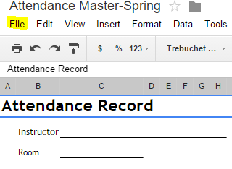
To share the link: In order to view the template on Blackboard, you will need to share the link.
- In the top right corner, click the button that says “share”.
- You should see the following screen. You will need to click the icon that says “get shareable link”.
- Copy the link
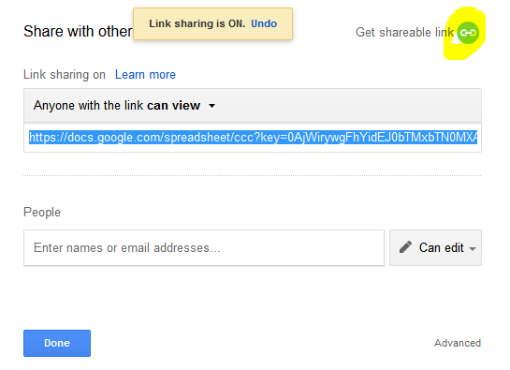
To insert the link into your Blackboard Course Menu:
- Click on the plus sign in the top upper left corner of your menu.
- Choose web link. 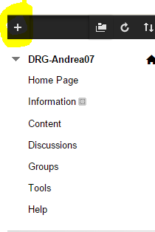
- Give it a name and paste in the URL for your spreadsheet from Google. Don’t make it available to users. This will be hidden to students, but during class you can access the spreadsheet to take attendance.
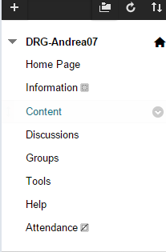
This symbol means this link is hidden from students
Advantages: The benefit of using a google sheet to take attendance is that it is updated automatically. You don’t need to save it and you don’t have to remember to save it on a flash drive or M drive. This template also prints very nicely at the end of the semester. You can download each template to an excel spreadsheet if you do not plan to use them in connection with Blackboard.
Disadvantages: You may need a google account and some knowledge of Google Drive to use this option. Another disadvantage to using a spreadsheet for attendance is that you may still need to enter a participation grade in Blackboard and you will have to build a manual column to do this. Students cannot view this spreadsheet as well, so they may not have an idea of how many classes they have missed.
NOTES
________________________________________________________________________________________________________________________________________________________________________________________________________________________________________________________________________________________________________________________________________________________________________________________________________________________________________________________________________________________________________________________
Attendance Templates are posted on Blackboard Babblings
Bb-Babblings Organization: Courses tab > click Bb-Babblings on the My Organizations module > Tips and Tricks> Attendance Options in the Blackboard Grade Center
For more specific questions contact: Andrea Gilbert agilbert14@monroecc.edu

