Reviewer Instructions
A step-by-step guide to reviewing IITG/OER Impact Grant proposals

To get into the Foundant reviewing portal, go to: https://www.grantinterface.com/Home/Logon?urlkey=suny
Or if you are on the Academic Innovation Grants website, navigate to “RFP Application Portal”.

The login page for Foundant looks like this:
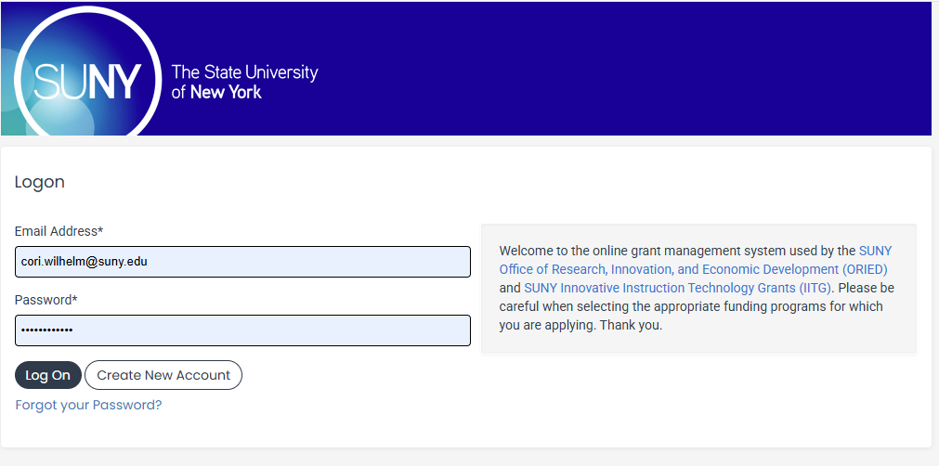
If you are a returning Foundant user, you can login with your previous account credentials. If you forgot your password, just click on the “Forgot your Password” link and the system will send your password to the email address on record in the system.

If this is your first time logging into the portal, use the email address where this was sent as your username and the default password: spring2027

Many reviewers have dual roles both as previous or current applicants, but reviewers have “Evaluator” status.
If you are both an applicant and reviewer, make sure you select “Evaluator” to see the proposals you have to review.
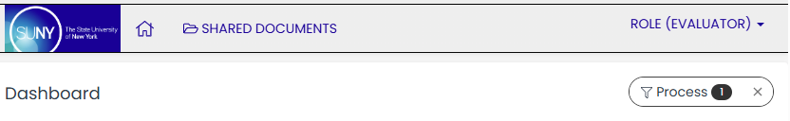

The number of reviews you have will appear in the red “pending” bar.
To begin a review, click on “Start”.
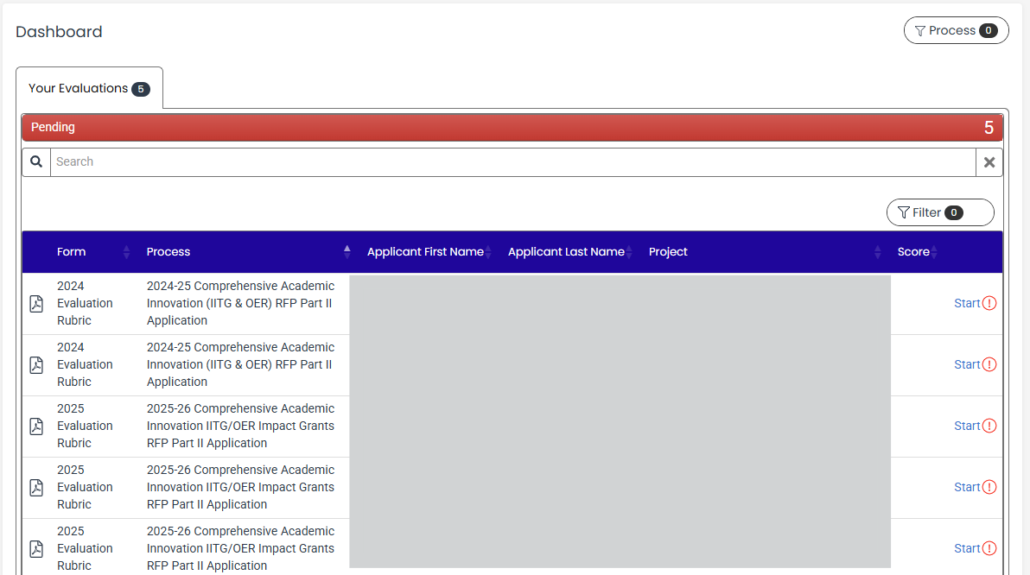

You will now see “Your Evaluation” in one box, and “Application” in another.
You can view the application by scrolling through the box, or by clicking the “Application Packet” icon, which will open the full application in another tab.
To complete the review, please scroll through the questions and select your rating from 1-5 for each section. There is also space for optional comments.
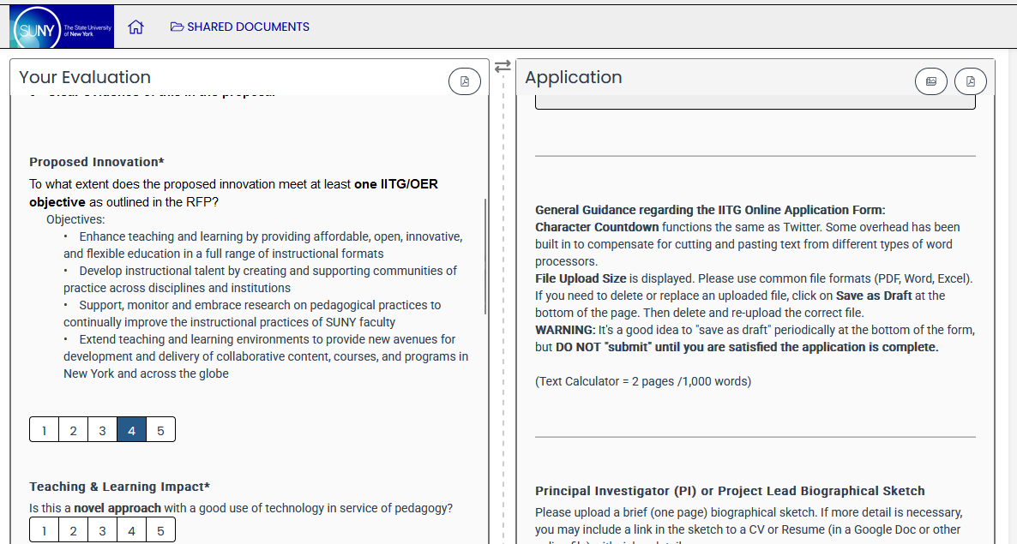
After you complete the required evaluation questions and save them, the review dashboard will show that review as complete. You will be able to make changes to your completed reviews until the review deadline. 