This Survey is designed to gather information about students’, and potential students’, learner characteristics and relationship with technology.
Participation in this survey is completely voluntary.
You may refuse to answer any question by skipping the question. You may discontinue your involvement at any time, without penalty or loss of benefits to which you might otherwise be entitled, by quitting your browser.
To ensure anonymity, do not put your name anywhere in this survey. All responses are confidential.
The survey will take about 15 minutes to complete.
Submission of answers to these questions constitutes your consent to participate in the validation process.
Lead Researcher contact information:
Melissa J. Miszkiewicz
miszkimj@buffalostate.edu

If you are unable to contact the researcher and have concerns or complaints about the research study, or questions about your rights as a research subject, please email the IRB Administrator at gina@rf.buffalostate.edu

First, we would like you to answer some questions regarding how you feel about college in general.

- How important is it to you to get a college degree?

Not at all Somewhat Quite Extremely
important important important important

- What grades do you expect to get in your college classes?

Mostly A’s Mostly Mostly B’s Mostly Mostly C’s Other
A’s and B’s B’s and C’s

The next few questions ask you to look ahead. Please indicate how likely it is that you will do, have, or be as suggested in the next three questions.

How likely is it…

- …that you will use technology in all of the courses you will take in college?

Very Somewhat Somewhat Very
Unlikely unlikely likely likely

- … that you will use technology in all of the courses you will take in college?

Very Somewhat Somewhat Very
Unlikely unlikely likely likely

- …that using a computer and technology will be part of any future job you have?

Very Somewhat Somewhat Very
Unlikely unlikely likely likely

In this next section, we’d like you to answer some questions about how those close to you feel about college in general.

- how important is it to your family that you get a college degree?

Not at all Somewhat Quite Extremely
important important important important

- In general, how important is it to your friends that they get college degrees?
Not at all Somewhat Quite Extremely
important important important important

- How useful do you believe the knowledge you gain in college will be in your life?
Not at all Somewhat Quite Extremely
useful useful useful useful

- How important do you believe your college degree is in helping you achieve your goals in life?
Not at all Somewhat Quite Extremely
important important important important

The next questions are about technology. Please indicate how important the next statements are to you, personally.

How important is it to you…

- … to be proficient with the Internet and the devices you use to access it?
Not at all Somewhat Quite Extremely
important important important important

- … to be able to learn the most current technology (e.g., computers, tablets, lasers, scanners, networks, etc.) as it relates to your field of study or work?
Not at all Somewhat Quite Extremely
important important important important

- …that your peers recognize you as someone who is fluent with computer and mobile devices like smart phones?
Not at all Somewhat Quite Extremely
important important important important

Please indicate how much you agree or disagree with each of the next statements.

- I have a great deal of control over my academic performance in my classes.
Strongly Agree Disagree Strongly
Agree Disagree

- The more effort I put into my classes, the better I do in them.
Strongly Agree Disagree Strongly
Agree Disagree

- No matter what I do, I can’t seem to do well in my classes.
Strongly Agree Disagree Strongly
Agree Disagree

- I see myself as largely responsible for my performance throughout my college career.
Strongly Agree Disagree Strongly
Agree Disagree

- How well I do in my classes is often the “luck of the draw.”
Strongly Agree Disagree Strongly
Agree Disagree

- There is little I can do about my performance in college.
Strongly Agree Disagree Strongly
Agree 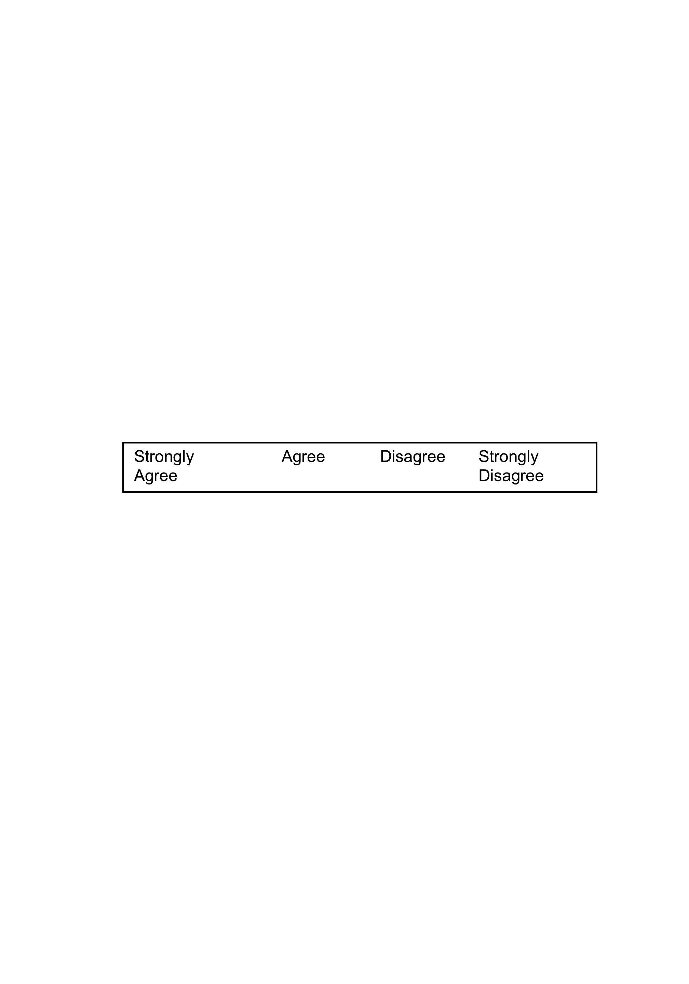 Disagree

- When I do poorly in a class, it’s usually because I haven’t given it my best effort.
Strongly Agree Disagree Strongly
Agree Disagree

- My grades are basically determined by things beyond my control, and there is little I can do to change that.
Strongly Agree Disagree Strongly
Agree Disagree

The next questions are about technology (e.g., computers, iPads, smart phones, etc.). Please indicate how much you agree or disagree with the following statements. disagree with each of the next four statements.

- When I am asked to download new software that I’m not familiar with, I find a way to get it done.
Strongly Agree Disagree Strongly
Agree Disagree

- Even when my computer isn’t working, I find a way to get my assignments done.
Strongly Agree Disagree Strongly
Agree Disagree

- If I can’t find an assigned article online, I look elsewhere.
Strongly Agree Disagree Strongly
Agree Disagree

- When the technology I’m using isn’t working, there is nothing I can do until it starts working again.
Strongly Agree Disagree Strongly
Agree Disagree

These next questions ask how well you believe you do certain class-related activities. We are not asking how capable you are of doing these activities, but rather how well you actually do them.

How well do you…

- …finish homework assignments by deadline?
Poorly Adequately Well Very Well

- …study when there are other interesting things to do?
Poorly Adequately Well Very Well

- …concentrate on school subjects?
Poorly Adequately Well Very Well

- …take notes of in-class instruction?
Poorly Adequately Well Very Well

How well do you…

- …use the library to get information for class assignments?
Poorly Adequately Well Very Well

- …plan your schoolwork?

Poorly Adequately Well Very Well

- …organize your schoolwork/
Poorly Adequately Well Very Well

- …remember information presented in class and textbooks?
Poorly Adequately Well Very Well

How well do you…

- …arrange a place to study without distractions?
Poorly Adequately Well Very Well

- …motivate yourself to do schoolwork?
Poorly Adequately Well Very Well

- …participate in class discussions?
Poorly Adequately Well Very Well

- …understand the main ideas and important issues of readings without guidance
from the instructor?
Poorly Adequately Well Very Well

How well do you…

- …express your opinion in writing to others?
Poorly Adequately Well Very Well

- …work in a group as a contributor of your fair share of work?

- …actively communicate when working as part of a group?
Poorly Adequately Well Very Well
Poorly Adequately Well Very Well

- …complete tasks independently?
Poorly Adequately Well Very Well

- …give appropriate feedback to others, even when you disagree?
Poorly Adequately Well Very Well

The next set of questions asks how comfortable you are doing certain activities using any kind of technology (e.g., radio, television, iPad, computer, etc.).

How comfortable are you…

- …downloading and installing new software on your computer or other device?
Not at all Somewhat Very Perfectly
Comfortable comfortable comfortable comfortable

- …finding and listening/watching assigned audio or video resouces on the Internet?
Not at all Somewhat Very Perfectly
Comfortable comfortable comfortable comfortable

- …using social networking sites such as Facebook, Twitter, Flickr, or others like them?
Not at all Somewhat Very Perfectly
Comfortable comfortable comfortable comfortable

The next set of questions ask how well you do certain activities using any kind of technology (e.g., radio, television, iPad, computer, etc.).

How well do you

- …complete your assignments using a tablet (iPad, Galaxy, Surf, Kindle, etc.?)
Not at all Somewhat Very Perfectly I don’t complete my assignments on a tablet

- …complete your assignments using a smartphone (i.e., iPhone or Droid)
Not at all Somewhat Very Perfectly I don’t complete my assignments on a smart phone

- …follow along and take notes from electronic books or articles, PowerPoint slides, or video productions (e.g., movies, television shows, YouTube videos, etc.), or audio (i.e., podcasts or other audio files)?
Not at all Somewhat Very Perfectly

- …review information you find on the Internet (i.e., for legitimacy and integrity) before using it in an assignment?
Not at all Somewhat Very Perfectly

- …understand the pros and cons of using social networking sites such as Facebook, Twitter, Flickr, and/or others like this?
Not at all Somewhat Very Perfectly

Optional to Institutions
ICTe Frequency of Use Questions
These questions ask you how often you do certain activities that use technology.

How often do you…

- … interact with social media (e.g., Facebook, Twitter, etc.)?
Every Day | 2-6 days per week | Once per week | Every 2-3 weeks | Once per month | Less than monthly | Never

- …have access to the Internet?
Every Day | 2-6 days per week | Once per week | Every 2-3 weeks | Once per month | Less than monthly | Never

- …post video clips to the Internet (i.e., upload clips from your phone or computer to Facebook, YouTube or other sites)?
Every Day | 2-6 days per week | Once per week | Every 2-3 weeks | Once per month | Less than monthly | Never

- …look for learning opportunities online (e.g., video tutorials on YouTube or other sites, podcasts, iTunesU, etc.)?
Every Day | 2-6 days per week | Once per week | Every 2-3 weeks | Once per month | Less than monthly | Never

- …create or manage a Web site?
Every Day | 2-6 days per week | Once per week | Every 2-3 weeks | Once per month | Less than monthly | Never

Thank you for your participation! Please quit your browser to ensure your privacy.

