IITG 2012 End of Project Report

Title of the IITG 2012 project
IL Fox – The Virtual Toolbook for Information Literacy Initial Research

Description (Abstract)
This IITG funded project consisted of conducting preliminary research into the development of an online information literacy (IL) toolbook to promote information and digital fluency. At this time there is no comprehensive information resource to support students’ information literacy needs. This tool is designed to fill a void for students as well as faculty at the statewide, national, and international levels. It will incorporate key information literacy concepts at multiple levels. First, it will provide a dictionary defining pertinent words and terms from the information literacy curriculum, such as proximity searching and cyberterrorism. Second, each dictionary definition will link to a supporting encyclopedia entry detailing each term, with an overview, history, and relevant examples. Additionally, the entries will contain sections designed to spark deeper thinking for student exploration by hyperlinking to relevant sources (for example, the page for Fair Use could link to the online video A Fair(y) Use Tale). Lastly, for pedagogical purposes, the resource will provide access to definition-specific lesson plans (best practice examples) to foster sharing and collaboration across SUNY campuses and beyond.

Project Overview
Having knowledge of information literacy concepts and principles is necessary education for all effective citizens. The IL Fox resource will provide the essential vocabulary elements for the information literate individual. The online resource is a pedagogical tool for users of all ages. It provides the young learner with the essential vocabulary to begin exploring the digital world; the high school student with fundamental aspects and skills to navigate information tools; the college student with more advanced knowledge of concepts and principles of information literacy; and the lifelong learner (the main goal of information literacy) with an authoritative resource to access for future informational needs.
There is currently no centralized informational resource supporting student information literacy needs. IL Fox will fill this gap statewide, nationally and globally, by presenting key ideas at several levels. First, the dictionary level will provide definitions of relevant IL terms, as noted above. Secondly, each of these concepts will link to a corresponding encyclopedia entry. These entries will also have sections to stimulate further student learning by hyperlinking to additional sources. Finally, the majority of entries will be authored by experts, thus providing an experience for students with authorities in information literacy domains. IL Fox will be an online educational resource that is freely available to anyone at any time, regardless of socioeconomic or geographical status.

Project Update
Throughout 2012 and most of 2013, the IL Fox team laid the groundwork for the project. We initially worked on the development of lists for IL Fox terms and then the identification of field experts. We encounter many challenges throughout the process.

IL FOX Terms
Yet, we persevered. One challenge related to Information Literacy itself, a field not limited to one subject area. Because of this, a wide variety of resources were required for its development. At the start of the project, the PIs anticipated the identification of approximately 500 information literacy terms/experts. As the research unfolded, we discovered many more pertinent terms (thousands) to add to the collection. From this initiative, we learned about the diverse aspects of this discipline. Since we are lifelong learners, this has been very enjoyable!
Static Terms
In the research process, the PIs identified over 2000 appropriate IL terms. Approximately 20% were labeled “static” (terms with little anticipated changes, e.g., magazine).Since the chance of change is limited for these terms, they would require less maintenance. A sample of static terms is as follow:
Beta Testing
Bibliology
Circa
Circulate
Circulating Materials
Email Quota
Embed
In-text Citations
Introduction
JPEG
Narrower Term (NT)
Nelson, Ted
Nesting
Revise
Rollover Image
Scanner
TV Parental Guidelines
Under-reported
Unglue.it - DELETE
WYSIWYG
Yearbook

Dynamic Terms
The remaining terms were more dynamic in nature and are expected to change over time (e.g., copyright policy). These terms would require the adoption of an expert in the term’s respective field who would commit to researching and writing about the topic as well as maintaining the entry over time. A sample of dynamic terms follows:
3D Printing
3D Technology
404 Not Found
Academic Freedom
Academic Integrity
Brain Machine Interface
Brainstorming
Collaborative Filtering
Collaborative Information Seeking
Denial of Service (DoS) attack
Derivative Work
Historical Fiction
Historical Revisionism

Term Adopters
Static Terms
For the static terms, our intent is to contact graduate schools and ask for a collaborative effort with Library and Information Science (LIS) and Education department faculty (including SUNY Albany and SUNY Buffalo), to engage the graduate students. We will ask that in the courses, students will complete an assignment within which they will research and author the definitions and encyclopedia entry for a specific term. The students will use the criteria for tone and style drafted in our research (see Appendix A). As a part of the research, we drafted several static terms using this criteria (see Appendix B) so that we would better understand how students would complete this assignment.
This opportunity provides a unique pedagogical experience for prospective information science and education professionals. Through these collaborative efforts, the static terms will be uploaded by the student creators.
Dynamic Terms
In the initial research, the PIs identified domain-specific experts to author the dynamic terms. In the second phase of the project, we will contact these experts, via email, to request their participation. As experts for the dynamic terms complete authorship of their respective terms, the finalized definitions and encyclopedia entries will be uploaded onto the site (See Appendix C for sample dynamic term/expert list). By the end of the second phase of the project, a minimum of 500 key terms will contain definitions/encyclopedia entries and made available online.
The selection of terms and corresponding experts involved reviewing the literature, professional associations, and websites from a wide range of disciplines, a process requiring time and care. There was also a wide range among the terms, which vary by discipline and complexity. It has been thought-provoking to create materials flexible enough to account for this scope, and has required drafting differently scaled versions of several documents. The process of developing criteria and templates for authors has been equally complex, requiring a wide review of online and print sources, and multiple draft revisions. Since the PIs want IL Fox to be a unified application, we worked meticulously on drafting term development criteria that would promote comprehensive and coherent entry results (see Appendix D for Dynamic Term Author Criteria). Locating contact information for some of the identified “experts” also took more time than anticipated. In many cases, technology has moved past email and individuals are listing Twitter information rather than an email contact address. In addition, many of those who do list an email address do so through a more cryptic text-based mode to deter spam.
In addition, since we knew that we would be conducting outreach efforts for unsolicited authors, we created a Google Form https://docs.google.com/forms/d/1FU5DkdutO6bB2sQSo87EstMupHhstIsuIQF2f-zm13k/viewform for individuals who would like to volunteer to be potential authors. In the interest in being consistent in looking to have experts as authors, we queried a volunteer’s level of expertise within a specialized area, and academic and authorship background. From that information we could either appoint a specific term to match their interests or make contact to find a good fit.
Editing/ Review
Standards of scholarly integrity will be needed to produce and maintain an authoritative resource. This will include the drafted criteria drafted as well as the creation of editing and review measures. The editing/review principles will be developed at the start of the second phase and implemented immediately. In addition, the PIs will select a review board, consisting of IL and related-field professionals, who will use the criteria focusing on accuracy, clarity, and consistency to evaluate the scholarship of the submitted terms (see Appendix E for outreach of Potential Reviewers). As with the solicitation of authors, we created a Google Form at https://docs.google.com/forms/d/1977aZZumfGfP2nkjebK0q-_b-hM2jycbKgm2k5101yo/viewform as a review for reviewers. This information will help to solicit needed and qualified reviewers. The editing process will be ongoing.
Collaborations and Outreach Efforts
Many collaborative connections were explored during the research phase of this project. This included inter-SUNY connections (call for authors and reviewers); interdepartmental connections (request for student engagement in the project); and inter-collegial associations (work with LIS program faculty and students). The final project will include extensive collaborative efforts with experts in the fields of information literacy, computer science, and information technology. Two key areas of collaboration were interdepartmental collaboration and student collaboration. Our systems expert noted, that since he “mainly works with information technology this provided an excellent venue for collaborating with content-based academics.” Future collaborations are planned, and will involve working with experts identified as potential authors.
In fall/spring of 2012/2013, we attended 3 conferences and delivered 3 presentations and one poster session. These were conducted at NYLA 2012, CIT 2013 and SUNYLA 2013. The slides for the NYLA presentation are in Appendix F, the SUNYLA and CIT conference poster/presentations are on the IITG site.
One of the most beneficial collaborations came from a graduate student in the College of Computing and Information. He worked on developing our interface and backend (more details below).

Assessment/Usability Initiatives
Assessment and usability will occur at several stages to evaluate the effectiveness of IL Fox, as well as user satisfaction. During the research phase, usability testing materials and IRB forms were drafted; these will be submitted upon approval of the phase 2 of the project (see Appendix G for Usability Testing survey and script). For the usability testing, subjects will be recruited from University at Albany courses to gauge the success of the interface. In the latter stages of the initial project stage, the PIs will create pre and post-tests to assess the knowledge users gain from accessing IL Fox. This instrument will also be submitted for IRB approval. Furthermore IL Fox will also be submitted for review to PRIMO and MERLOT (peer review of instructional tools), and presented at the 2014 SUNYLA and SUNY CIT conferences for evaluation and feedback.
IL FOX Technology
Another challenge is the care needed in selecting the appropriate information technology tools that will make this an easy to use resource for content creators (scholars in the field) and end users. We will monitor this thoughtfully through the next several phases of the project.
For phase one of the project, the intent was to research available technologies and identify the best possible resource, taking finances, feasibility, and user experience into account. We also need to draft a concept plan so we could define and articulate our needs to designers and developers.
IL Fox Concept Plan
The initial task will be the creation of a platform. It will be created with three option points: a searching/browsing feature, a dictionary definition listing, and a corresponding encyclopedia entry structure. A working version of the tool will be created, using human-computer interface design with a focus on usability and accessibility standards. The PIs will determine the layout and syntax of site elements and levels of interactivity. The criteria templates created in phase one of eth project for terms, definitions, and encyclopedia entries will be coded and uploaded. Usability testing during the early stages of the project will enable improvements for user satisfaction. The technical work will also take into account planning and design for future use and maintenance, which will include link-checking and update notifications.
Technology Review
To determine the best technical options for IL Fox, the PIs evaluated several content management systems (CMS’s). This involved the creation of a focused bibliography and use of online comparison tools and reviews, both for potential platforms and to get a more detailed idea of what technical considerations might exist for this project. Nine select applications were reviewed for information such as cost, customizability and availability of templates, scalable permission-setting, and ability to manage multiple file types. Sites currently using each application were investigated, and vendor interviews took place to gain further insight into capabilities and limitations. Costs ranged from free, open source software for creating a bare-bones wiki to $25,000 per year for a full-featured learning management system. Features varied widely, both in terms of which were included and whether they were customizable (see Appendix H- Technology Application Review). Ultimately, two CMS’s were selected for continued investigation for possible IL Fox use: Omeka, and Drupal.
Omeka is a free, open source CMS that could be customized for our needs; but it has significant technical limitations, and the interfaces for user login and upload are reported to be problematic. Drupal is also free and open source, with the ability to meet all the needs of IL Fox, and the advantage of current use and expertise among the University at Albany Libraries. Negatives to consider are the greater time costs involved (compared to using out-of-the box options), and issues relating to server space.
At the end of the review, Drupal appeared to be the best option for IL Fox. The high customizability and lack of purchase cost are significant, and the greater time requirements are compensated for by the depth of in-house familiarity with this CMS. In the current stage of research, maintenance considerations are being investigated including concerns relating to server space, issues with user uploads, and an analysis of the costs for developing and maintaining IL Fox that will address future personnel, technology, and assessment expenditures. The work done the next stage was expected to bring up new considerations that may alter which platform was ultimately chosen.
After the completion of phase one, the PIs, worked on their own time to move the project forward. A strategy for the technology component was to enlist the assistance of a University at Albany student from the Department of Information Studies (technology track) to bring the interface to fruition. We were able to get a highly skilled computer programmer to take on this aspect of the project. The Independent project consisted of the development of an interface and backend of a web-based for IL Fox. Chris Abel's task was to develop a working online platform, for both users and content creators. It was produced with three option points: a searching/browsing feature, a dictionary definition listing with a corresponding encyclopedia entry structure, and an alphabetical listing for authors and terms. The working version, at https://chrisabel.net/ilfox/, was developed using human-computer interface design with a focus on usability and accessibility standards.
Mr. Abel met and exceeded the expectations of this project. He developed a clean interface which will be easy for both the novice and expert to navigate. His composition of the IL Fox technology addresses the needs of end users, content creators, and reviewers. In its development, Chris took into account all of the IL Fox Team's requests. More details about his use of technology applications are highlighted on his Developer Blog. This was an extensive project and we are aware of additional adjustments to come and hope that we can continue to partner with Chris. As highlighted in the Developer Blog postings, Chris was a serious student and professional in this project. As he noted, he could have used applications that he had a strong familiarity with using. Instead, he chose to learn about new technology applications and applied them in this process. I am highly impressed with his learning initiatives Team has been very impressed with Chris's work ethic and were delighted that he embraced this project with as much joy as we have.
This interface is still at the preliminary stages. We are negotiating with Mr. Abel to see if he can work this project into an internship for his graduate work. Once this is more stable, we can move forward with soliciting experts and content integration. Currently, IL Fox is hosted on Mr. Abel’s server, we will need to find a more permanent location.
IL FOX Team
One of the project’s strengths was its diverse research team, comprised of a seasoned librarian, a library technology wizard, and a new librarian. Determining how to best use each member’s skills collaboratively has been a key aspect, resulting in a clear shared vision. Soliciting input from all members, even on facets not obviously related to one person’s expertise, has been invaluable. A direct result of this was increased knowledge of IT and computer terms than anticipated; with over 2100 terms, IL Fox is a comprehensive resource that will benefit many disciplines.
In discussing this project with colleagues at SUNY and other academic institutions, we found a lot of excitement for the project and interest from faculty who are anxious to link into this source as a key information literacy tool for faculty and students.

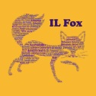
Appendix A – Graduate Faculty Outreach Letter w/ Student Term Assignment
University at Albany Libraries
Innovative Instruction Technology Grants
IL Fox – The Virtual Toolbook for Information Literacy
Dear Faculty Member,
We are contacting you with a unique pedagogical opportunity for you and your students.
In July 2012, we were awarded a SUNY Innovative Instruction Technology Grant to research the development of IL Fox: an online information literacy (IL) dictionary and encyclopedia.
This resource is intended to:
- promote information literacy and digital fluency
- define pertinent words and terms from information literacy and technology curriculum
- provide encyclopedia elements, examples, and relevant web links
From the research, we generated a list of over 2000 terms to be defined. We have divided this list into two groups of terms: dynamic terms to be assigned to experts for definition/entry creation and upkeep, and static terms (e.g., magazine) to be assigned to LIS students to author. We are hoping that you will be interested in including your students in assisting with this project.
Please find attached an assignment for use in an LIS course (see reverse). Often, LIS students create pathfinders for courses; this could be one element of that resource. It is designed to be a term-length assignment, with students developing the components over the semester for a cumulative outcome. The assignment is designed to teach research skills, and requires students to:
- research one term from the toolbook
- find authoritative physical and online resources relating to the term
- create a dictionary definition for the term
- produce an encyclopedia entry for the term
- formulate a bibliography with correct citations
- provide links to related authoritative sources
We hope you find this to be an interesting assignment for your students. All assignments that meet the editorial board criteria will be added to IL Fox, giving students an opportunity for publication in a new resource related to their field.
Please let us know if you are interested in this collaborative effort. We look forward to working with you and your students as future partners in this exciting project. Please contact us for further information.
Sincerely,
Carol Anne Germain, PhD, Information Literacy Librarian (cgermain@albany.edu)
Tor Loney, Information Literacy Librarian (tloney@albany.edu)

Student Definition/Encyclopedia Entry Assignment
Overview
For this assignment, you will create a dictionary definition and encyclopedia entry for IL Fox, a new online information literacy dictionary and encyclopedia. The creators of IL Fox are seeking additions to the dictionary/encyclopedia, and the content you create will be considered for inclusion. This assignment gives you a rare opportunity to be published in a new resource related to your field.
General Guidelines
- Definitions and entries should be original work, written in your own words
- Intended audience: students unfamiliar with information literacy or library terminology
- Language should be objective and neutral, using the third-person
- Terms should be kept lower-case, unless used to begin a sentence
- Bibliography sources used must be authoritative print editions, rather than online
- Use correct APA style for in-text citations and bibliography
- Throughout, identify words that should hyperlink to other IL Fox pages using format described below
Definition Guidelines:
Definitions should be brief, use a few complete sentences, and be under 100 words.
- TERM (provide term to be defined)
- DEFINITION (include succinct definitions for any variations of the term, if applicable)
Encyclopedia Entry Guidelines:
Entries should be more comprehensive in scope and include relevant material such as and links and references. They should contain the following headings (all-caps, bold, in the order listed below):
- TERM (provide term to be defined)
- OVERVIEW (expanded definition. Add italicized subheadings, if needed. Up to 400 words)
- HISTORY (term origin and evolution, if applicable. Up to 400 words)
- SUBCATEGORIES (with headings in italics, if applicable.)
- CONTEXT & EXAMPLES (when, where, and why this is used, with bulleted examples of actual use)
- LEGAL ASPECTS (notable legal considerations and history, if applicable)
- ECONOMIC ASPECTS (notable economic considerations and history, if applicable)
- SOCIAL ASPECTS (social impact and history, if applicable)
- ADDITIONAL INFORMATION (additional relevant information not listed elsewhere, if applicable)
- RELATED TERMINOLOGY (1-5 other terms of possible interest, separated by semicolons)
- RELATED WEB RESOURCES (Optional. Academic websites closely related to information literacy or a more specific subject area directly relating to the term itself. URLs should go directly to the relevant page)
- BIBLIOGRAPHY (minimum of 5 APA-style citations, in alphabetical order)
Please also provide an author’s bio of no more than 50 words, including your name, institutional affiliation, research interests, and publications (if any). On a separate line, please provide your email address.

Appendix B – Completion of Student Term Assignment – Term Capitalization
TERM
Capitalization
DEFINITION
The practice of displaying a letter using its upper case form. Capitalization can also refer using the upper case for the first letter of a word.
OVERVIEW
The use of capital letters, also known as the upper case or majuscule, either for every letter of a word or just its first letter. Capitals are not necessarily larger than lower case letters, but instead use a different form for a given letter.¹ Capitalization is generally used to give emphasis, in accord with the original Latin meaning of “relating to the head or top.”² Capital letters are sometimes referred to as caps, with the practice of capitalizing every letter of a word referred to as using all-caps.
HISTORY
Capital letters existed before lower case (or miniscule). In the early Roman alphabet all letters were capitalized, with lower case letters being introduced in the Middle Ages.³ Alphabets with only one case are known as unicase; current examples include Hebrew and Arabic.⁴ Usage conventions for capitalization vary by language, geography, and field of use, and have evolved continually since their inception.⁵
CONTEXT & EXAMPLES
In English, standard conventions include capitalizing proper nouns and the first words of sentences:
- The first president of the United States was George Washington.
CONTEXT & EXAMPLES (continued)
Titles for articles/books/films are generally capitalized when mentioned in a sentence:
- One of Mark Twain’s best-known works is The Adventures of Tom Sawyer.
Titles for persons are typically capitalized, but only when referring to a specific person:
- Tom’s aunt was known in the book as Aunt Polly.
The word “I” is typically capitalized:
- Although E.E. Cummings referred to himself as “i,” most of us use “I.”
Capitalization of every letter, or using all-caps, is sometimes used to give stronger emphasis or to connote shouting.
- That pizza last night was the absolute BEST.

SOCIAL ASPECTS
Texting on mobile devices has brought about new uses of capitalization, for abbreviations such as LOL (laugh out loud) and TMI (too much information). Additionally, conventional capitalization is often omitted in texting, with proper nouns and the first words of sentences frequently expressed using lower case letters.⁶
ADDITIONAL INFORMATION
Capitalization is a component of citation styles, and correct usage varies for these. Links are provided below for several style guides.
RECOMMENDED RELATED TERMS
all-caps; caps; lower case; upper case; typography
RELATED WEB RESOURCES
The Chicago Manual of Style Online: http://www.chicagomanualofstyle.org/qanda/data/faq/topics/Capitalization.html?old=Titles/CapitalizationTitles23.html
The University at Albany’s Citation page: http://library.albany.edu/usered/cite/index.html
BIBLIOGRAPHY
1. Hamilton, F. W. (1918). Capitals: A primer of information about capitalization, with some practical typographic hints as to the use of capitals. Chicago: Committee on education, United typothetae of America.
2. Capitalize. (n.d.). In Oxford English dictionary. Retrieved from http://www.oed.com/view/Entry/27459?
3. Jensen, H. (1969). Sign, symbol, and script: An account of man's efforts to write. New York: Putnam.
4. Ambrose, G., & Harris, P. (2010). The visual dictionary of typography. Lausanne, Switzerland: AVA Pub.
5. Garner, B. A. (2000). The Oxford dictionary of American usage and style. New York: Oxford University Press.
6. Crystal, D. (2008). Txtng: The Gr8 Db8. Oxford: Oxford University Press.

Appendix C – Select List of Terms and Identified Experts

Appendix D for Dynamic Term Author Criteria
University at Albany Libraries
Innovative Instruction Technology Grants
IL Fox – The Virtual Toolbook for Information Literacy
Dear Expert,
We are contacting you with an opportunity for professional engagement.
In July 2012, we were awarded a SUNY Innovative Instruction Technology Grant to research the development of IL Fox: an online information literacy (IL) dictionary and encyclopedia.
This resource is intended to:
- promote information literacy and digital fluency
- define pertinent words and terms from information literacy and technology curriculum
- provide encyclopedia elements, examples, and relevant web links
From the research, we generated a list of over 2000 terms to be defined. We are seeking experts to create definitions and encyclopedia entries for these, and are hoping you will be interested in contributing to this. We also believe your participation will benefit you, by providing:
- authorship in a peer-reviewed encyclopedia
- an opportunity to extend your knowledge to others
- involvement in a pedagogical collaboration
To give you a clearer idea of what the entries will look like, we have attached our author’s outline and an example of a term definition and entry.
If you are interested in contributing, please let us know. Simply scan this QR code or go to the URL:
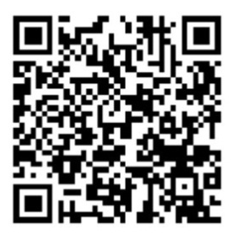
http://is.gd/authors

You can also email us directly at either address below. Feel free to ask any questions. And please feel free to share this with any colleagues you feel may be interested.
We look forward to hearing from you!
Sincerely,
Carol Anne Germain, PhD, Information Literacy Librarian (cgermain@albany.edu)
Tor Loney, Information Literacy Librarian (tloney@albany.edu)
Expert IL Fox Definition/Encyclopedia Entry Guidelines
General Guidelines
- All content must be in own words
- Intended audience: students unfamiliar with information literacy or library terminology.
- Language should be objective and neutral, using the third-person
- Terms should be kept lower-case, unless used to begin a sentence
- Use correct APA style for in-text citations and bibliography
- Please use print sources rather than online sources when possible
- Throughout, identify words that should hyperlink to other IL Fox pages using format described below
Formatting Guidelines:
Use these symbols to identify special formatting.
- Words that should hyperlink to other IL Fox pages: [H]example[H]
- Words that should be italicized: [I]example[I]
- Precede lines that should be bulleted with: [B]example
Definition Guidelines:
Definitions should use a few complete sentences and be under 100 words.
- TERM (provide term to be defined)
- DEFINITION (including succinct definitions for any variations of the term, if applicable)
Encyclopedia Entry Guidelines:
Entries should contain between 250 and 1500 words, using the following headings:
- TERM (provide term to be defined)
- OVERVIEW (expanded definition, with subheadings in italics, if needed. May include examples)
- HISTORY (term origin and evolution, if applicable)
- SUBCATEGORIES (with headings in italics, if applicable)
- CONTEXT & EXAMPLES (when, where, and why this is used, with bulleted examples of actual use)
- LEGAL ASPECTS (notable legal considerations and history, if applicable)
- ECONOMIC ASPECTS (notable economic considerations and history, if applicable)
- SOCIAL ASPECTS (social impact and history, if applicable)
- ADDITIONAL INFORMATION (additional relevant information not listed elsewhere, if applicable)
- TAKING IT FURTHER (Optional. Unique or detailed aspects related to the term)
- RELATED TERMINOLOGY (other terms of possible interest, separated by semicolons)
- RELATED WEB RESOURCES (academic websites closely related to information literacy or a more specific subject area directly relating to the term itself. URLs should go directly to the relevant page)
- BIBLIOGRAPHY (APA-style citations, in order of reference)
Please also provide an author’s bio of no more than 100 words, including your name, institutional affiliation, research interests, and select relevant publications. On a separate line, please provide your email address.

Appendix E Reviewer/Editorial Outreach and Criteria
University at Albany Libraries
Innovative Instruction Technology Grants
IL Fox – The Virtual Toolbook for Information Literacy
Dear Reviewer,
We are contacting you with an opportunity for professional engagement.
In July 2012, we were awarded a SUNY Innovative Instruction Technology Grant to research the development of IL Fox: an online information literacy (IL) dictionary and encyclopedia. This resource is intended to promote information literacy and digital fluency, define pertinent words and terms from information literacy and technology curriculum, and provide encyclopedia elements, examples, and relevant web links.
From the research, we generated a list of over 2000 terms to be defined. These range from simple, static terms (e.g., magazine) to more complex, dynamic terms such as copyright policy. Static term entries will be authored by LIS students, while dynamic terms entries will be created by experts in the appropriate field. All entries will be reviewed by members of the library and computer science community. We are currently seeking members to serve on this review board, and are hoping you will be interested in working with us. While your participation will help us greatly, we also believe it will benefit you, by providing:
- editorial experience
- membership in an encyclopedia review board
- involvement in a pedagogical collaboration
As a reviewer, you would be evaluating entries based on the following criteria: accuracy, objectivity, clarity, succinctness, readability, consistency, and originality, as well as correctness of citations and links. The general categories for review include:
- information literacy
- technology
- information policy
- librarianship
- scholarship
- technology policy
If you are interested in contributing, please let us know. Simply scan this QR code or go to the URL:
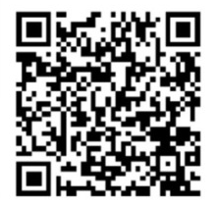
http://is.gd/reviewers

You can also email us directly at either address below. Feel free to ask any questions. And please feel free to share this with any colleagues you feel may be interested.
We look forward to hearing from you!
Sincerely,

Definition/Encyclopedia Entry Guidelines
General Guidelines
- All content must be in own words
- Intended audience: students unfamiliar with information literacy or library terminology.
- Language should be objective and neutral, using the third-person
- Terms should be kept lower-case, unless used to begin a sentence
- Use correct APA style for in-text citations and bibliography
- Please use print sources rather than online sources when possible
- Throughout, identify words that should hyperlink to other IL Fox pages using format described below

Formatting Guidelines:
Use these symbols to identify special formatting.
- Words that should hyperlink to other IL Fox pages: [H]example[H]
- Words that should be italicized: [I]example[I]
- Precede lines that should be bulleted with: [B]example
Definition Guidelines:
Definitions should use a few complete sentences and be under 100 words.
- TERM (provide term to be defined)
- DEFINITION (including succinct definitions for any variations of the term, if applicable)
Encyclopedia Entry Guidelines:
Entries should contain between 250 and 1500 words, using the following headings:
- TERM (provide term to be defined)
- OVERVIEW (expanded definition, with subheadings in italics, if needed. May include examples)
- HISTORY (term origin and evolution, if applicable)
- SUBCATEGORIES (with headings in italics, if applicable)
- CONTEXT & EXAMPLES (when, where, and why this is used, with bulleted examples of actual use)
- LEGAL ASPECTS (notable legal considerations and history, if applicable)
- ECONOMIC ASPECTS (notable economic considerations and history, if applicable)
- SOCIAL ASPECTS (social impact and history, if applicable)
- ADDITIONAL INFORMATION (additional relevant information not listed elsewhere, if applicable)
- TAKING IT FURTHER (Optional. Unique or detailed aspects related to the term)
- RELATED TERMINOLOGY (other terms of possible interest, separated by semicolons)
- RELATED WEB RESOURCES (academic websites closely related to information literacy or a more specific subject area directly relating to the term itself. URLs should go directly to the relevant page)
- BIBLIOGRAPHY (APA-style citations, in order of reference)

Appendix F – 2012 NYLA Conference Presentation Slides
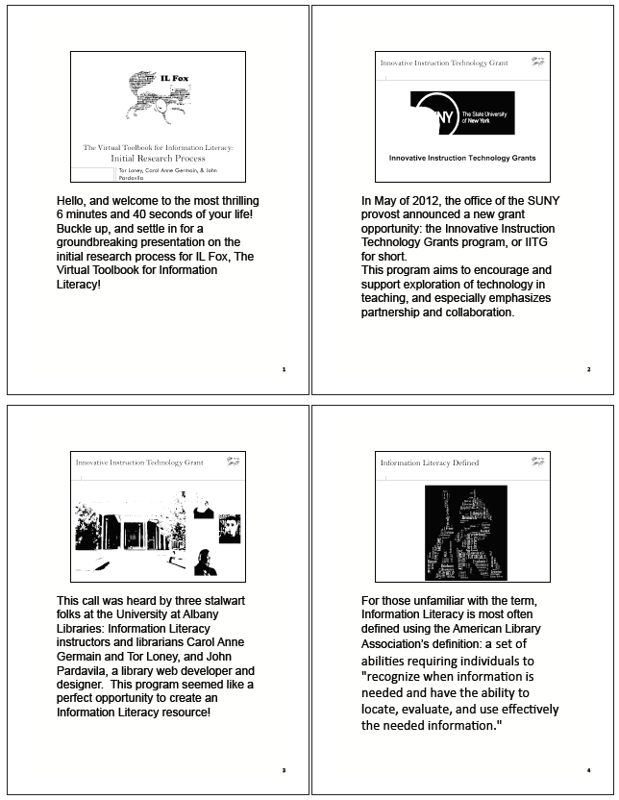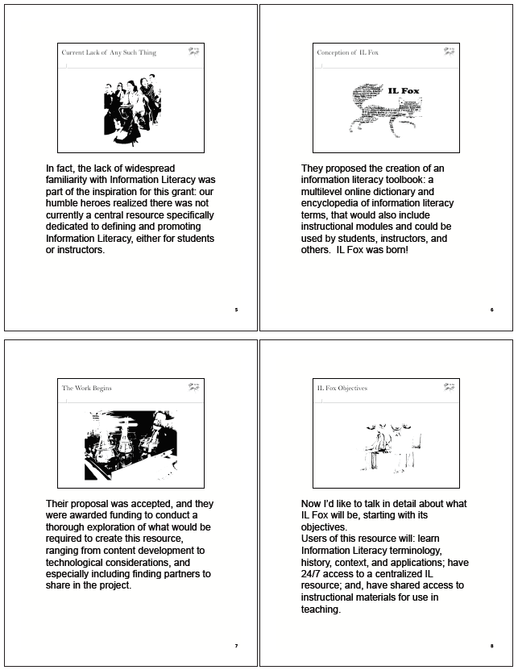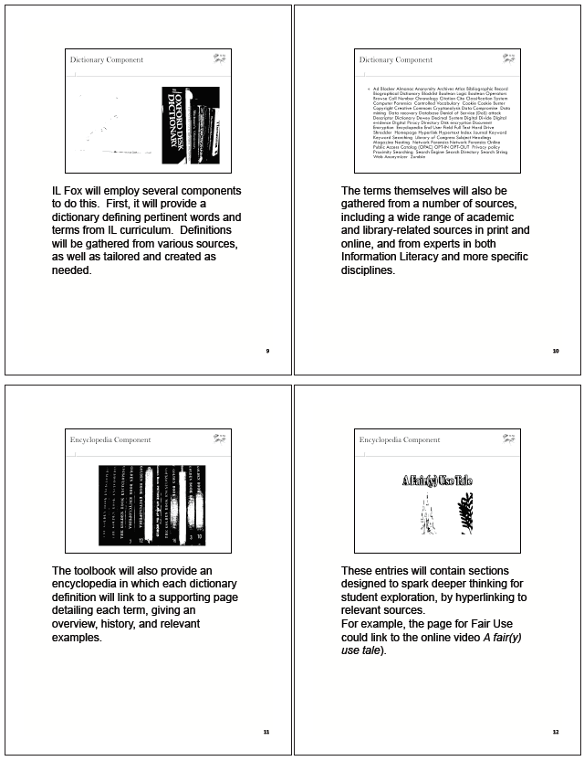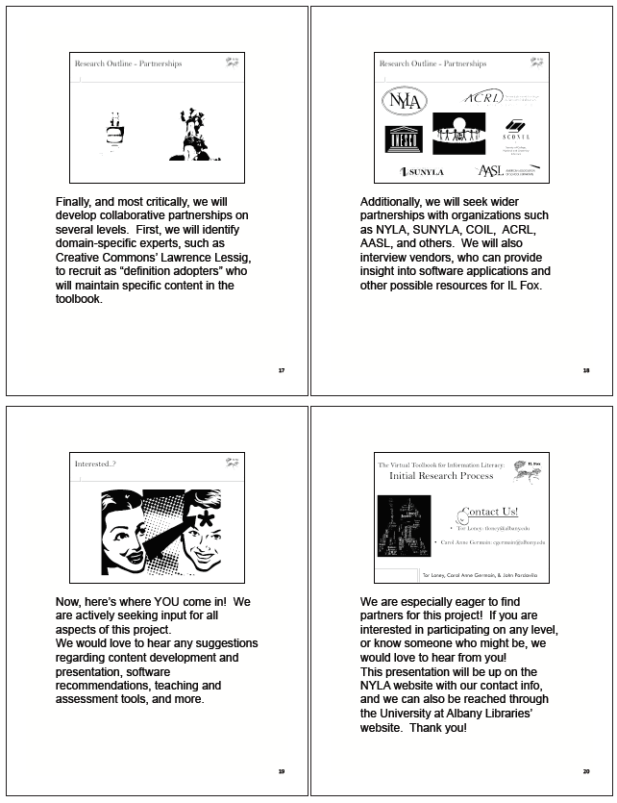
Appendix G –Usability Testing Survey
Background Information
AGE (Circle one):
19 or younger 20-23 24-30 30 or older
NUMBER OF COLLEGE CREDITS COMPLETED (Circle one):
1-15 credits 16-30 credits 31-45 credits 46-60 credits more than 60
GENDER (Circle one):
Female Male
TYPICAL NUMBER OF HOURS OF COMPUTER USE EACH WEEK (Circle one):
0-1 hours 2-5 hours 6-9 hours 10-13 hours more than 13
I HAVE TAKEN CREDIT-BEARING COURSES THAT SPECIFICALLY TAUGHT
THE FOLLOWING (Circle all that apply):
Databases Internet Searching Tools Mathematical or Statistical Software
Computer Programming Word Processing/Spreadsheets
I HAVE COMPLETED THE INFORMATION LITERACY GENERAL EDUCATION
REQUIREMENT (Circle one):
Yes No
RATE THE FOLLOWING ON A SCALE OF 1-5 (1 = Not Familiar, 5 = Very Familiar)
_____ Email _____ Windows _____ Apple _____ Word Processor
_____ World Wide Web _____ Unix/Linux _____ Statistical Software
_____ Citation _____ Plagiarism _____ Copyright _____ Fair Use
I HAVE WORKED IN A LIBRARY (Circle one):
Yes No
I AM FAMILIAR WITH REFERENCE MATERIALS (Circle one):
Yes No Unsure
I AM COMFORTABLE USING THESE KINDS OF DICTIONARIES (Circle all that apply):
Print Online Neither
I AM COMFORTABLE USING THESE KINDS OF ENCYCLOPEDIAS (Circle all that apply):
Print Online Neither
I HAVE USED THE FOLLOWING FOR ACADEMIC RESEARCH (Circle all that apply):
Books in a library The help of a librarian Library databases Online Resources
I HAVE USED THE FOLLOWING DATABASES (Circle all that apply):
EBSCO LexisNexis JSTOR ERIC SCOPUS LISTA

Tasks
(Researcher asks each question and records verbal responses and actions taken)
- What is the dictionary definition for Book?
- How would you find the dictionary definition for Plagiarism?
- Find the encyclopedia entry for Net Neutrality.
- Find the dictionary definition for Boolean Operator. Now find the encyclopedia entry. Now return to the dictionary definition.
- How many terms begin with the word “Internet?”
- How would you find the history of the term Library 2.0?

- If you had to write a paper about Fair Use, what strategy would use?
- Who created the encyclopedia entry for Open Source?

- How many total terms are defined in this resource?
- How would you browse the full list of terms?
Final Impressions
(Answered after task portion is completed)

- In general, did you find it easy to navigate this resource? What did you like? What didn’t you like?
- What functions do you wish would be added? If there were a button for each of these, what would you label it?

- Does this seem like a reliable resource to use for research? Why or why not?

Appendix H- Technology Application Review
